Change Log

| **Revision** | **Submission Date** | **Affected Sections or Pages** | **Change Summary** |
| --- | --- | --- | --- |
| Initial | 06 /12 / 2019 | All | Initial issue of document. |

Table of Contents

1 Document Overview 1

1.1 Identification 1

1.2 Purpose 1

1.3 Overview 2

1.4 Terminology and Definitions 5

1.5 References 8

2 Current System 9

2.1 Context 9

2.2 Description of Current Activity Planning tool 9

2.3 Description of The Current Sequence Validation Tool 11

3 Development and Execution Stages of A Mission 12

3.1 Mission Planning 13

3.2 Operations 15

4 Mission Adaptations 19

4.1 Development of Mission Adaptations 19

4.2 Format 19

4.3 Activity Types 20

4.4 Mission Specific and Common State/Resource Models 22

4.5 Model Orchestration And Simulation 22

4.6 Scheduling 22

4.7 Defining, checking Constraints & Opportunity Window Detection 23

4.8 Ownership and Collaboration 23

4.9 Versioning 24

4.10 Roles Involved 24

4.11 Command Models and Sequence Adaptations 24

4.12 Summary of Capabilities Needed 25

5 Activity Planning 26

5.1 Level of Complexity in Activity Planning 27

5.2 Plan Instantiation 27

5.3 Activity Instantiation And Editing 27

5.4 Resource Visualization 28

5.5 Scheduling 28

5.6 Constraint Editing 28

5.7 Review Plan Simulation / Scheduling results 29

5.8 Collaboration In Planning 29

5.9 Plan Progression and Approval 31

5.10 Roles Involved & Permissions 31

5.11 Capabilities Needed in Activity Planning 31

6 Sequencing 33

6.1 Sequence Generation 33

6.2 Sequence Delivery and Collaboration 34

6.3 Backbone or Background Sequence Generation & Sequence Integration 34

6.4 Sequence Validation And Flight Rules 34

6.5 Review Sequence Simulation Results 35

6.6 Generation of Uplink Products and Reports 35

6.7 Capabilities Needed in Sequence Generation and Validation 35

6.8 Capabilities Needed in Uplink Product Generation 36

7 Spacecraft Analysis 37

7.1 Downlink Data Types 37

7.2 Goals of Spacecraft Analysis 38

7.3 Variations in downlink operations 38

7.4 Desired Capabilities for Downlink Operations 39

7.5 Summary of Needed Capabilities 40

8 General Design Principles for Aerie 40

8.1 Background, Objectives, and Scope 40

8.2 Operational Policies and Constraints 40

8.3 Desired Characteristics of the Aerie Platform 40

8.4 Reusable UI Features 41

8.5 Summary of Impacts 46

8.6 Operational Impacts 46

9 Conclusions 47

Table of Tables

Table 1: Applicable JPL Rules Documents 8

Table 2: Applicable MGSS Documents 8

# 

# Document Overview

## Identification

| **Property** | **Value** |
| --- | --- |
| Configuration ID (CI) | TBD |
| Element | MPSA |
| Program Set | Aerie |

## Purpose

MPSA element of MGSS is tasked with developing new tools to support activity planning, sequencing, and spacecraft analysis of mission operations. Activity planning and sequencing operations are dependent on mission adaptations that describe the behaviour of a spacecraft at activity and command level consecutively. The challenge of MPSA is to provide an adaptation framework for many missions with diverging needs to adopt and describe their activity and command models according to mission specific needs. Furthermore, MPSA will provide a set of web tools for mission scientists and engineers to interact with these mission specific adaptations while performing operations. Hence, second challenge of MPSA is to ensure a structured framework such that our web tools can interface with the mission adaptations seamlessly, despite adaptations serving each mission differently.

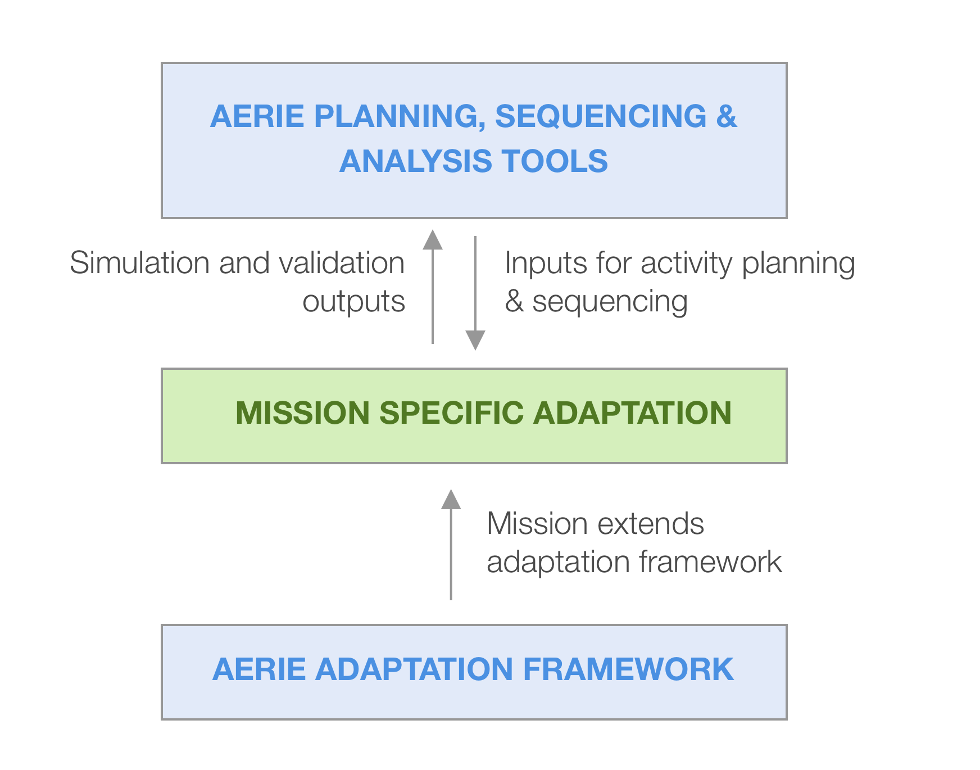

Figure 1: Aerie System provides both the adaptation framework and the user interface web tool. Missions own the adaptation that extends the framework.

The foremost purpose of this document is to inform the architecture design and requirements of both the adaptation framework and mission operations UI tools by outlining end user capabilities needed for mission planning and operations. To be able to guide the design and development of a multi-mission tool set, we investigated many different types of missions with diverse needs, focusing on questions such as how missions create adaptations, what purpose these adaptations serve during mission planning and operations, how they evolve over time. Our goal was to describe a nominal mission that can approximate to any mission planning and operations scenario to some extent. We classified common elements in mission adaptations and operations, and then described the variations across missions for each element. Ideally, these common elements should translate into components in our software, and variations in these elements should translate into capability requirements per component. Note that the operations concept focuses on required end user capabilities but does not aim to provide any design or implementation details on how Aerie is going to provide these capabilities.

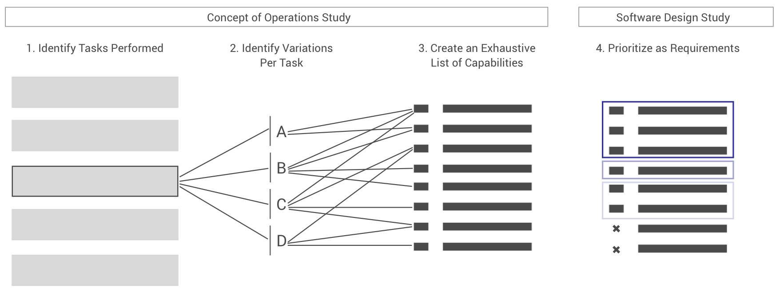

Figure 2 – The process and purpose of the operations concept study is to identify common tasks, their variations, capabilities needed to lead to requirements for a multi-mission tool.

The secondary purpose of the document is to provide a lexicon that describes common concepts with a standardized terminology in the domain of spacecraft mission planning and operations. Since many terms are overloaded with different meanings, or similar concepts are termed differently across missions or even sub-systems within missions, it becomes a challenge to communicate what is intended. Hence the document shall provide a common terminology to avoid confusion within our team, and with customers and stakeholders. In short, the purpose of this document can be summarized as follows:

1. Facilitate the understanding of the overall system goals among stakeholders, including mission customers, MPSA personnel, Section 397 and Division 39 Line management, and MGSS program management.
2. Summarize common concepts in a wide range of mission planning and operations with a consistent terminology.
3. Identify required end user capabilities to inform the design of a domain-driven, component-based software system architecture.
4. Help derive requirements to ensure coverage of capabilities needed and flexibility required per component.
5. Provide use case context for the Aerie requirements.

## Overview

**Aerie** is a software platform that will provide customer space missions with planning, sequencing, validation and analysis capabilities. The system adopts a component-based architecture, where several components can be packaged and customized to serve mission specific needs. The system can also interface with mission specific tools to achieve utmost flexibility in adaptation. **Aerie** is divided into backend components and services and front-end web components. These components will be packaged as product lines for activity planning (**Merlin**), sequencing (**Falcon**) and spacecraft analysis (**Eagle**). We plan to extend the product lines to cover science planning (**Osprey**) and operations process support (**Kite**) in the future. However, for the purposes of this document and our requirements, the latter two product lines are currently out of scope.

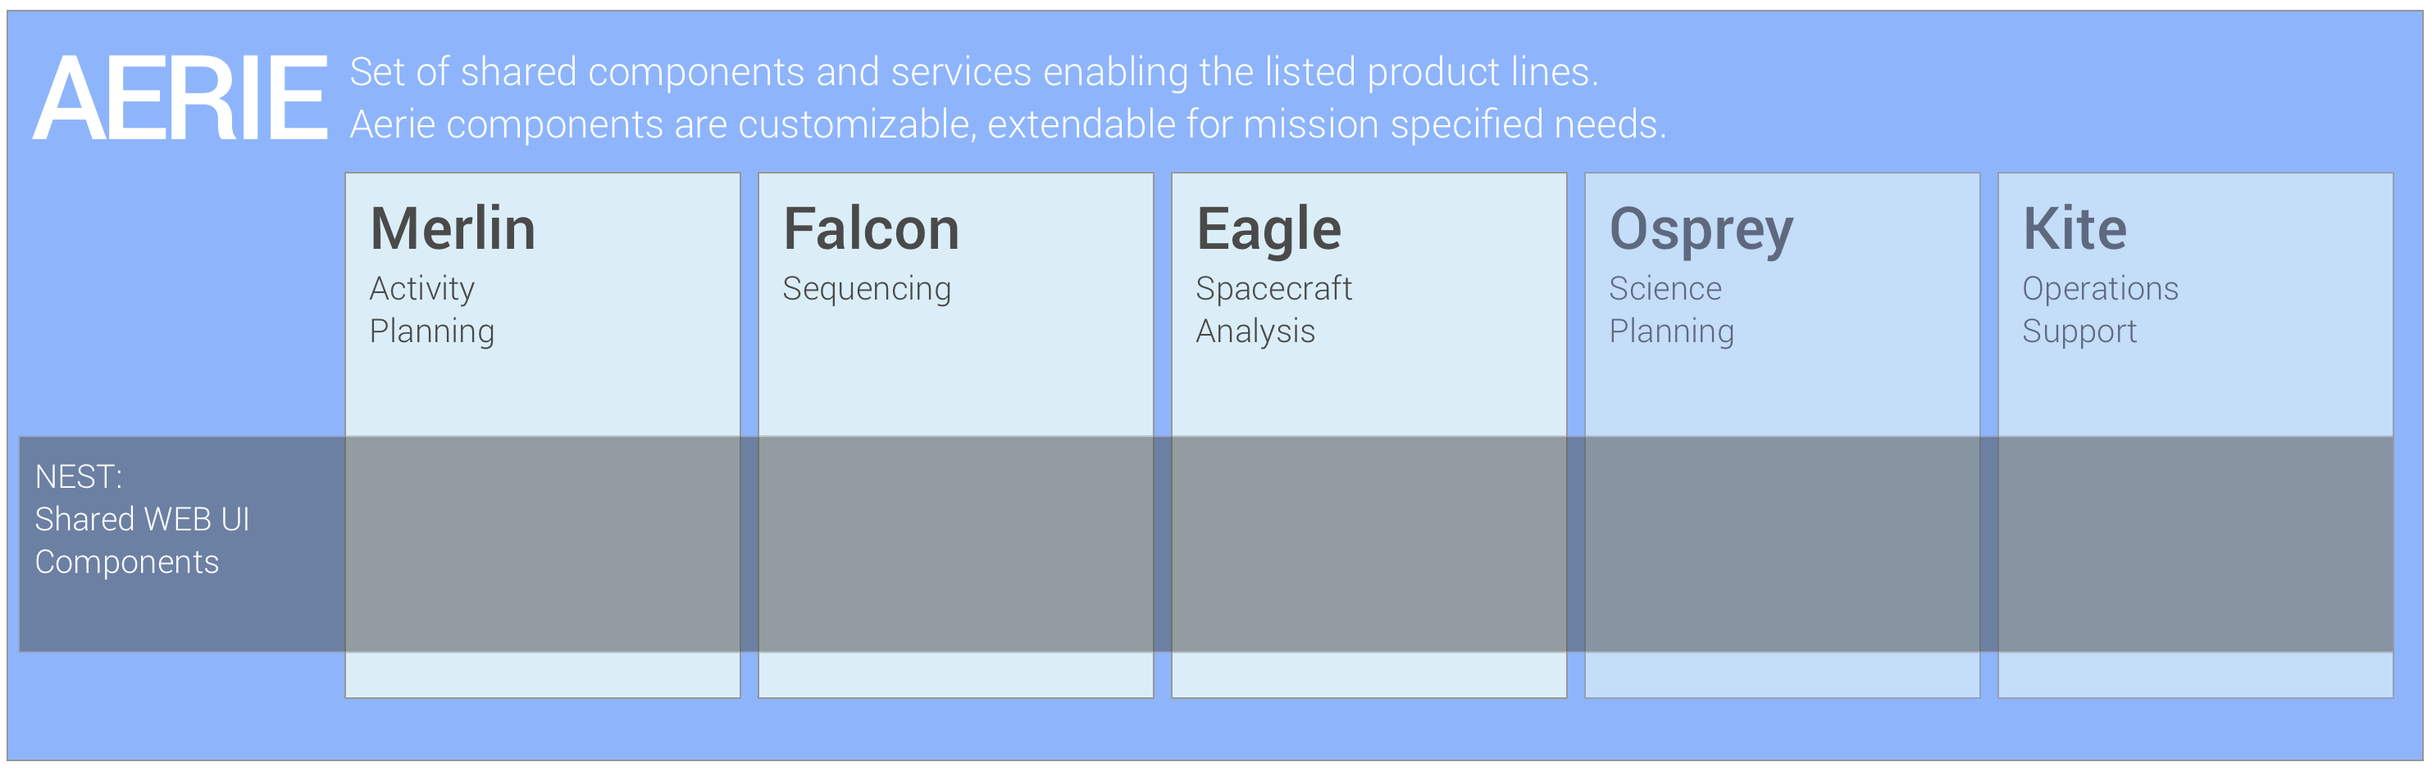

Figure 3 - AERIE software organization and product line branding.

Aiming to serve multiple missions with various complexity levels, **Aerie** must not be architected based on the needs of a single mission or a single concept of operations. Instead, the software platform should provide capabilities that serve a wide range of missions, while also allowing further flexibility by enabling missions to customize, extend Aerie components or even add on mission specific components.

For instance, missions can use the scheduling component provided with **Merlin**, or chose to extend this component to define a mission specific scheduling algorithm to use in their adaptation. Similarly, **Aerie** will provide a set of complete user interfaces designed to support canonical mission operations roles. Missions can easily customize their own views using the building block UI components. Additionally, missions can develop their custom UIs, and interface with the **Aerie** components and services through APIs.

The goal of this research study is to identify common mission planning and operations concepts, to guide the design of a component-based software architecture which can satisfy needs of a variety of missions, while allowing missions to extend and adapt our tools for mission specific needs. To this end we conducted interviews with representatives from a range of missions covering orbiters, landers, mature missions that have been in flight for several years, as well as younger missions that are in their early development phase. Table 1 provides a comprehensive list of interviewees who contributed to our research.

|  |  |  |
| --- | --- | --- |
| Interviews | Topic | Missions |
| Nathan Strange | Mission Planning Overview | Many |
| Jan Ludwinski | Europa Clipper and other Mission Planning | Europa Clipper and many others |
| Eric Ferguson, Ben Bradley | Europa Clipper Mission Planning | Europa Clipper |
| Priyanka Sharma | NISAR Mission Planning | NISAR |
| Rob Lange, Travis Wagner | Mars 2020 Mission Planning | M2020 |
| Forrest Ridenhour | Activity Model Adaptations | Insight, MRO, M2020 |
| Nick Rossomondo | MER Operations, MER APGEN Adaptation | MER |
| Steven Wissler | Activity Model Adaptations | Europa Clipper and many others |
| Scott Lever | MER Operations late stage | MER |
| Seung Chung | MER Operations early stage | MER |
| Jared Call | MRO Operations | MRO |
| John Kwok | ConOps Review | MRO, Insight |
| Rachel Kim | MRO Operations Review | MRO |
| Dave Mohr, Diane Connor, Sarah Schnadt | Europa Clipper Operations | Europa Clipper |
| Vic Voskanian, David Seal | Dawn and Psyche Operations | Dawn, Psyche |
| Brian Roth | Insight and MSL SEQGEN Adaptation | Insight, MSL |
| Chet Joswig | MSL MSlice | MSL |
| Kim Steadman | MSL and M2020 Science Operations | MSL, M2020 |
| James Biehl | MSL and M2020 Engineering Operations | MSL, M2020 |
| Maria Schellpfeffer | Mission Operations, JSOC | Juno |
| Teerapat Khanampornpan | Downlink Analysis | Many |
| Dan Allard | Downlink Analysis | MSL, Mars 2020, Europa Clipper |

Table 1: List of interviews conducted with various mission representatives, topic of discussions and missions.

The information that we collected through the interviews listed above is synthesized in this document to summarize how missions create adaptations, how they perform planning, sequencing and downlink analysis operations.

The next section of the document describes the current capabilities provided by AMMOS. Almost all capabilities that we describe in this document start forming and evolving long before operations begin. Section 3 provides context for mission design, implementation and operations timeline. Section 4 describe development, purpose and other properties of mission adaptations. Sections 5, 6, and 7 describe activity planning, sequencing and spacecraft operations consecutively. We describe common scenarios and variations across missions for each operational task. We provide an exhaustive list of capabilities needed to achieve each task.

## Terminology and Definitions

**Mission Planning:** Mission planning begins with conducting trade studies with approximately defined spacecraft specifications, trajectory and operation scenarios, to evaluate whether high level science goals can be met. The results help define more concrete specifications for the hardware and requirements for the mission operations. Over time, mission planning takes the form of strategic planning for the finalized mission specs, that covers the whole mission life cycle to ensure that mission can meet science goals.

**Spacecraft Resources / States:** Spacecraft resources / states refer to consumable, claimable or settable assets on a spacecraft that are affected by activity execution, and need to be tracked in activity plan simulations. Canonical examples include battery state of charge (consumable), remaining fuel (consumable), pointing state (settable) or robotic arm being in use (claimable). Each mission has a unique set of resources / states that needs to be modelled depending on specific limitation induced by hardware, environmental conditions or trajectory.

**External Resources / States:**  Various states of a spacecraft which can be encoded as a discrete enumeration or a profile over the course of time. An instrument being in use, or spacecraft pointing can be an example of the former type of state. Altitude of the spacecraft over the course of planning period can be an example of the latter type of state.

**Resource Effects:** Resource effects are the calculations predicting by how much and / or how long spacecraft resources will be utilized by one, multiple or all activities in the plan.

**Activity Type:** An abstracted unit operation that a spacecraft or instrument will perform. Activities are units for modeling and planning for the ground operations. Activities must be translated into sequences of commands before uplink. Granularity and fidelity of activities vary significantly based on needs. An activity can group many commands involving multiple instruments or sub-system, or can map to a single command. An Activity Type generally consists of:

1) **Parameters** that define how the activity can vary. Parameters either effect models or used for commanding. These are defined with allowed ranges and types.

2) **Attributes** are parameters that apply across all activity types.

3) **Constraints** are conditions that define when an activity can be or should be executed. Constraints often reference various spacecraft resources or states, describing which resources should be available at the time of activity execution. While some constraints will be defined at the activity type level, hence true for all instances, some additional constraints can be defined at the instance level of an activity.

4) **Effects** on resources and states that are input or computed by formulas / algorithms that reference activity parameters and states.

5) **Decomposition** describes how activities can be broken down into children activities. Decomposition can either describe an activity group consisting of atomic activities, or describe a scheduling logic for the activity type. Activity group decomposition is used to simplify activity modeling. For instance, a 3x3 and a 4x4 mosaic image activity can be expressed as combinations of same atomic activities modeled only once. Activity group decomposition is driven by activity parameters. Activity scheduling logic decomposition, on the other hand, is used to describe logic to schedule activities in a plan to satisfy constraints defined in the activity model, but is often dependent on the spacecraft resources and states at the time of scheduling.

**Activity Dictionary:** A markup encoding of activity parameters, attributes, constraints and effects for all activity types. Generally preferred when effects and constraints can be defined with simplified expressions.

**Activity Model Adaptation:** A compiled source that characterizes the behaviour of all activities that will be used in planning. The adaptation encodes the behavioural limits of activities (constraints) as well their effects on resources as captured in models. Activity model adaptations can be used to model any resource that is critical for a mission. Generally preferred to describe more expressive effects and constraints, also to improve performance. Traditionally APGEN used to define activity adaptations.

**Activity Instance:** An instance of an activity type that lives within the context of an *activity plan*. Activity instances are atomic units for planning and plan level simulations. Parameters, attributes of an activity instance can be edited within the plan context, within ranges defined by the activity type.

**Planning Constraints:** There are many types of constraints that an activity plan must adhere to. Some constraints are requirements for safe execution for an activity type. Others are global constraints ensuring overall safety of the spacecraft. Constraints can be defined for activity types, activity instances or a plan. Below is a summary of constraint types and corresponding examples:

1. **Temporal constraints**‘Activity Instance X can be performed between 9am to 2pm’
2. **Ordering constraints** ‘Activity Instance X can be performed after Activity Instance Y completes’
3. **Frequency constraints** ‘Plan should have three instances of Activity Type X’
4. **Geometric constraints** ‘Activity Type X can be performed when spacecraft is nadir pointing’
5. **Resource constraints** ‘Activity Type X can be performed only when state = value’
6. **Global constraints** ‘Maximum power load cannot exceed certain value’
7. **Composite constraints** these are combinations of above type of constraints with logic operators.

**Activity Groups:** Activities can be grouped together either in the plan context, or at the type level as templates, as logical groupings to achieve a larger science intent. For instance, scientist may want to take three observations from the same target using different instruments to collect comprehensive data. They may require these observations to be performed in a specific order, at a specific time with ideal conditions for the observation. The constraints described above can be used to create specific ordering and timing constraints between such activities.

**Activity Plan:** A plan that describes what a spacecraft will perform within a time period, using tokens of activity instances. A plan consists of

1. Activity instances,
2. Planning period,
3. Global constraints,
4. Plan-level scheduling constraints.

**Plan level resource constraints**: Plan level constraints describe resources or states that the spacecraft has to maintain at specific time points or throughout a plan. An example of a plan level constraint would be minimum state of charge allowed at any point in the plan or the handover state of charge desired at the time of plan completion.

**Plan level scheduling constraints**: Plan level scheduling constraints describe desired frequency and conditions for instantiation and scheduling of certain activity types. These can be a combination of constraint types described above.

**Planning Period:** The time period where activities in the plan will execute on board the spacecraft. While lander missions work with a day-long planning periods, orbiter missions can have much longer planning periods ranging from 2 weeks to six months.

**Plan Simulation (activity level):** An estimate of the resource effects of all activities in the plan based on initial conditions. Fidelity of this simulation depends on the quality of the models described per activity as well as the accuracy of initial conditions assumed.

**Constraint Checking:** Performed at two levels:

1. Activity Level: Given a plan context, checks performed per activity, to ensure that at the time of activity execution all necessary constraints will be satisfied.
2. Plan level: Given a plan (the whole set of activity instances), checks performed to ensure that plan level constraints are not violated.

**Initial Conditions:** Initial resource and state conditions of the spacecraft that are assumed at the beginning of a planning cycle. Initial conditions generally propagated from a known state reported at the last communication with the spacecraft, to the beginning of a plan.

**Final Conditions:** Given initial conditions and activity instances in the plan, propagated final state of the spacecraft at the end of a plan execution.

**Activity Modeling and Plan Validation:** For a given plan with scheduled activity instances:

1. perform modeling and scheduling,
2. track resources and state,
3. validate all constraints to ensure that plan is safe to execute, and achieves science goals.

Can be performed either by activity adaptations, such as provided by APGEN, or by computing and integrating expressions provided in the Activity Dictionary for a given activity schedule. Missions can utilize AMMOS software or mission specific tools to perform resource / state modeling and plan validation.

**Command:** A directive to the Flight Software to perform a unit task.

**Sequence:** A set of commands that are logically grouped together to instruct the spacecraft to perform a complex task. Often activity instances in the plan are mapped to a sequence. Hence, a sequence can be considered the implementation of a declared activity in the plan.

**Expansion:** An automated sequence generation from an activity in plan, where parameters of an activity are used to generate commands or mapped to command parameters. There are many types of expansions:

1. **Scripts or team tools**: Instructions to generate a set of commands for a given set of parameters. Most common scripts take activity instance parameters as input to generate commands.
2. **Templates**: Simple constructs that replace parameters of commands based on input parameters. Input parameters are often activity instance parameters.
3. **Ground blocks**: Part of an adaptation, generates a set of commands for given parameters. The expansion is performed on the ground, and resulting commands are radiated to the spacecraft.
4. **On-board blocks**: Part of flight software, generates a set of commands for given parameters. The expansion is performed on board based on parameters radiated.

**Sequence (Command) Model Adaptation:** Description of the behaviour of individual commands which depend on command arguments as well as external conditions such as spacecraft state or interactions with other commands. Sequence model adaptations often perform sequence simulation, integration and validation tasks described below. Traditionally SEQGEN tool is used for many missions to create a sequence adaptation. More recently stubbed FSW is being adopted by missions to simulate sequences on the ground as in case of Mars 2020.

**Simulation (Command Level):** Imitation of spacecraft behaviour based on assumed initial conditions, actual commands and their models. The output of simulation is often a step by step command walkthrough, possible validation outputs encoded in models and resource profiles along the way.

**Sequence Integration:** Sequences are developed for various science and engineering activities separately. These sequences are invoked by a backbone sequence which is often generated automatically. Sequence integration refers to generation of the backbone sequence combining all the individual sequences.

**Sequence Validation:** Steps involved in ensuring that all sequences in the plan are safe to execute. While some validation steps can be direct output of simulation, others might require post processing of simulation outputs such as the sequence tree, or the list of predicted events.

**Flight Rule:** A limitation imposed on an operations team regarding the way a spacecraft can be commanded. Flight rules not only encode expected Flight Software faults and exceptions, but also encode ground-imposed limitations and best practices for commanding. They are often related to parameters, timing and state requirements of a command, or ordering and parallelism between commands.

**Uplink Product:** Data product ready to be radiated to a spacecraft, generally a package in a format readable by the spacecraft. The legacy Spacecraft Message File (SCMF) format is recently being replaced by the CLTUF format.

**Telemetry:** Refers to all of the data that is downlinked from the spacecraft. Everything delivered by radio is telemetry. This definition has not always been agreed upon. Telemetry is sometimes restricted to channelized data formats.

**EHA (Engineering Health and Accountability) Data:** Specific telemetry that is used to assess health and safety of the spacecraft.

**EVR (Event Records):** Log files produced by the flight software that indicate invocation, success, failures, alarms and warnings.

## References

Table 1: Applicable JPL Rules Documents

| **Title** | **DocID** |
| --- | --- |
| Software Development | 57653 REV 9 |
| Institutional Project System Engineering Mangement Plan (IPSEMP) | 75012 REV 2 |

Table 2: Applicable MGSS Documents

| **Title** | **Doc. Number** |
| --- | --- |
| MGSS Implementation and Maintenance Task Requirements | DOC-001455 REV C |
| MPSA Strategic Plan | DOC-002099 |

# Current System

## Context

Planning is a Ground Data System (GDS) function provided by the AMMOS. Ground Data Systems is responsible for providing Mission Operations System (MOS) with software tools. Within the larger context of MOS, GDS focuses on the Planning and Sequencing, which can be decomposed as shown in Figure 4.

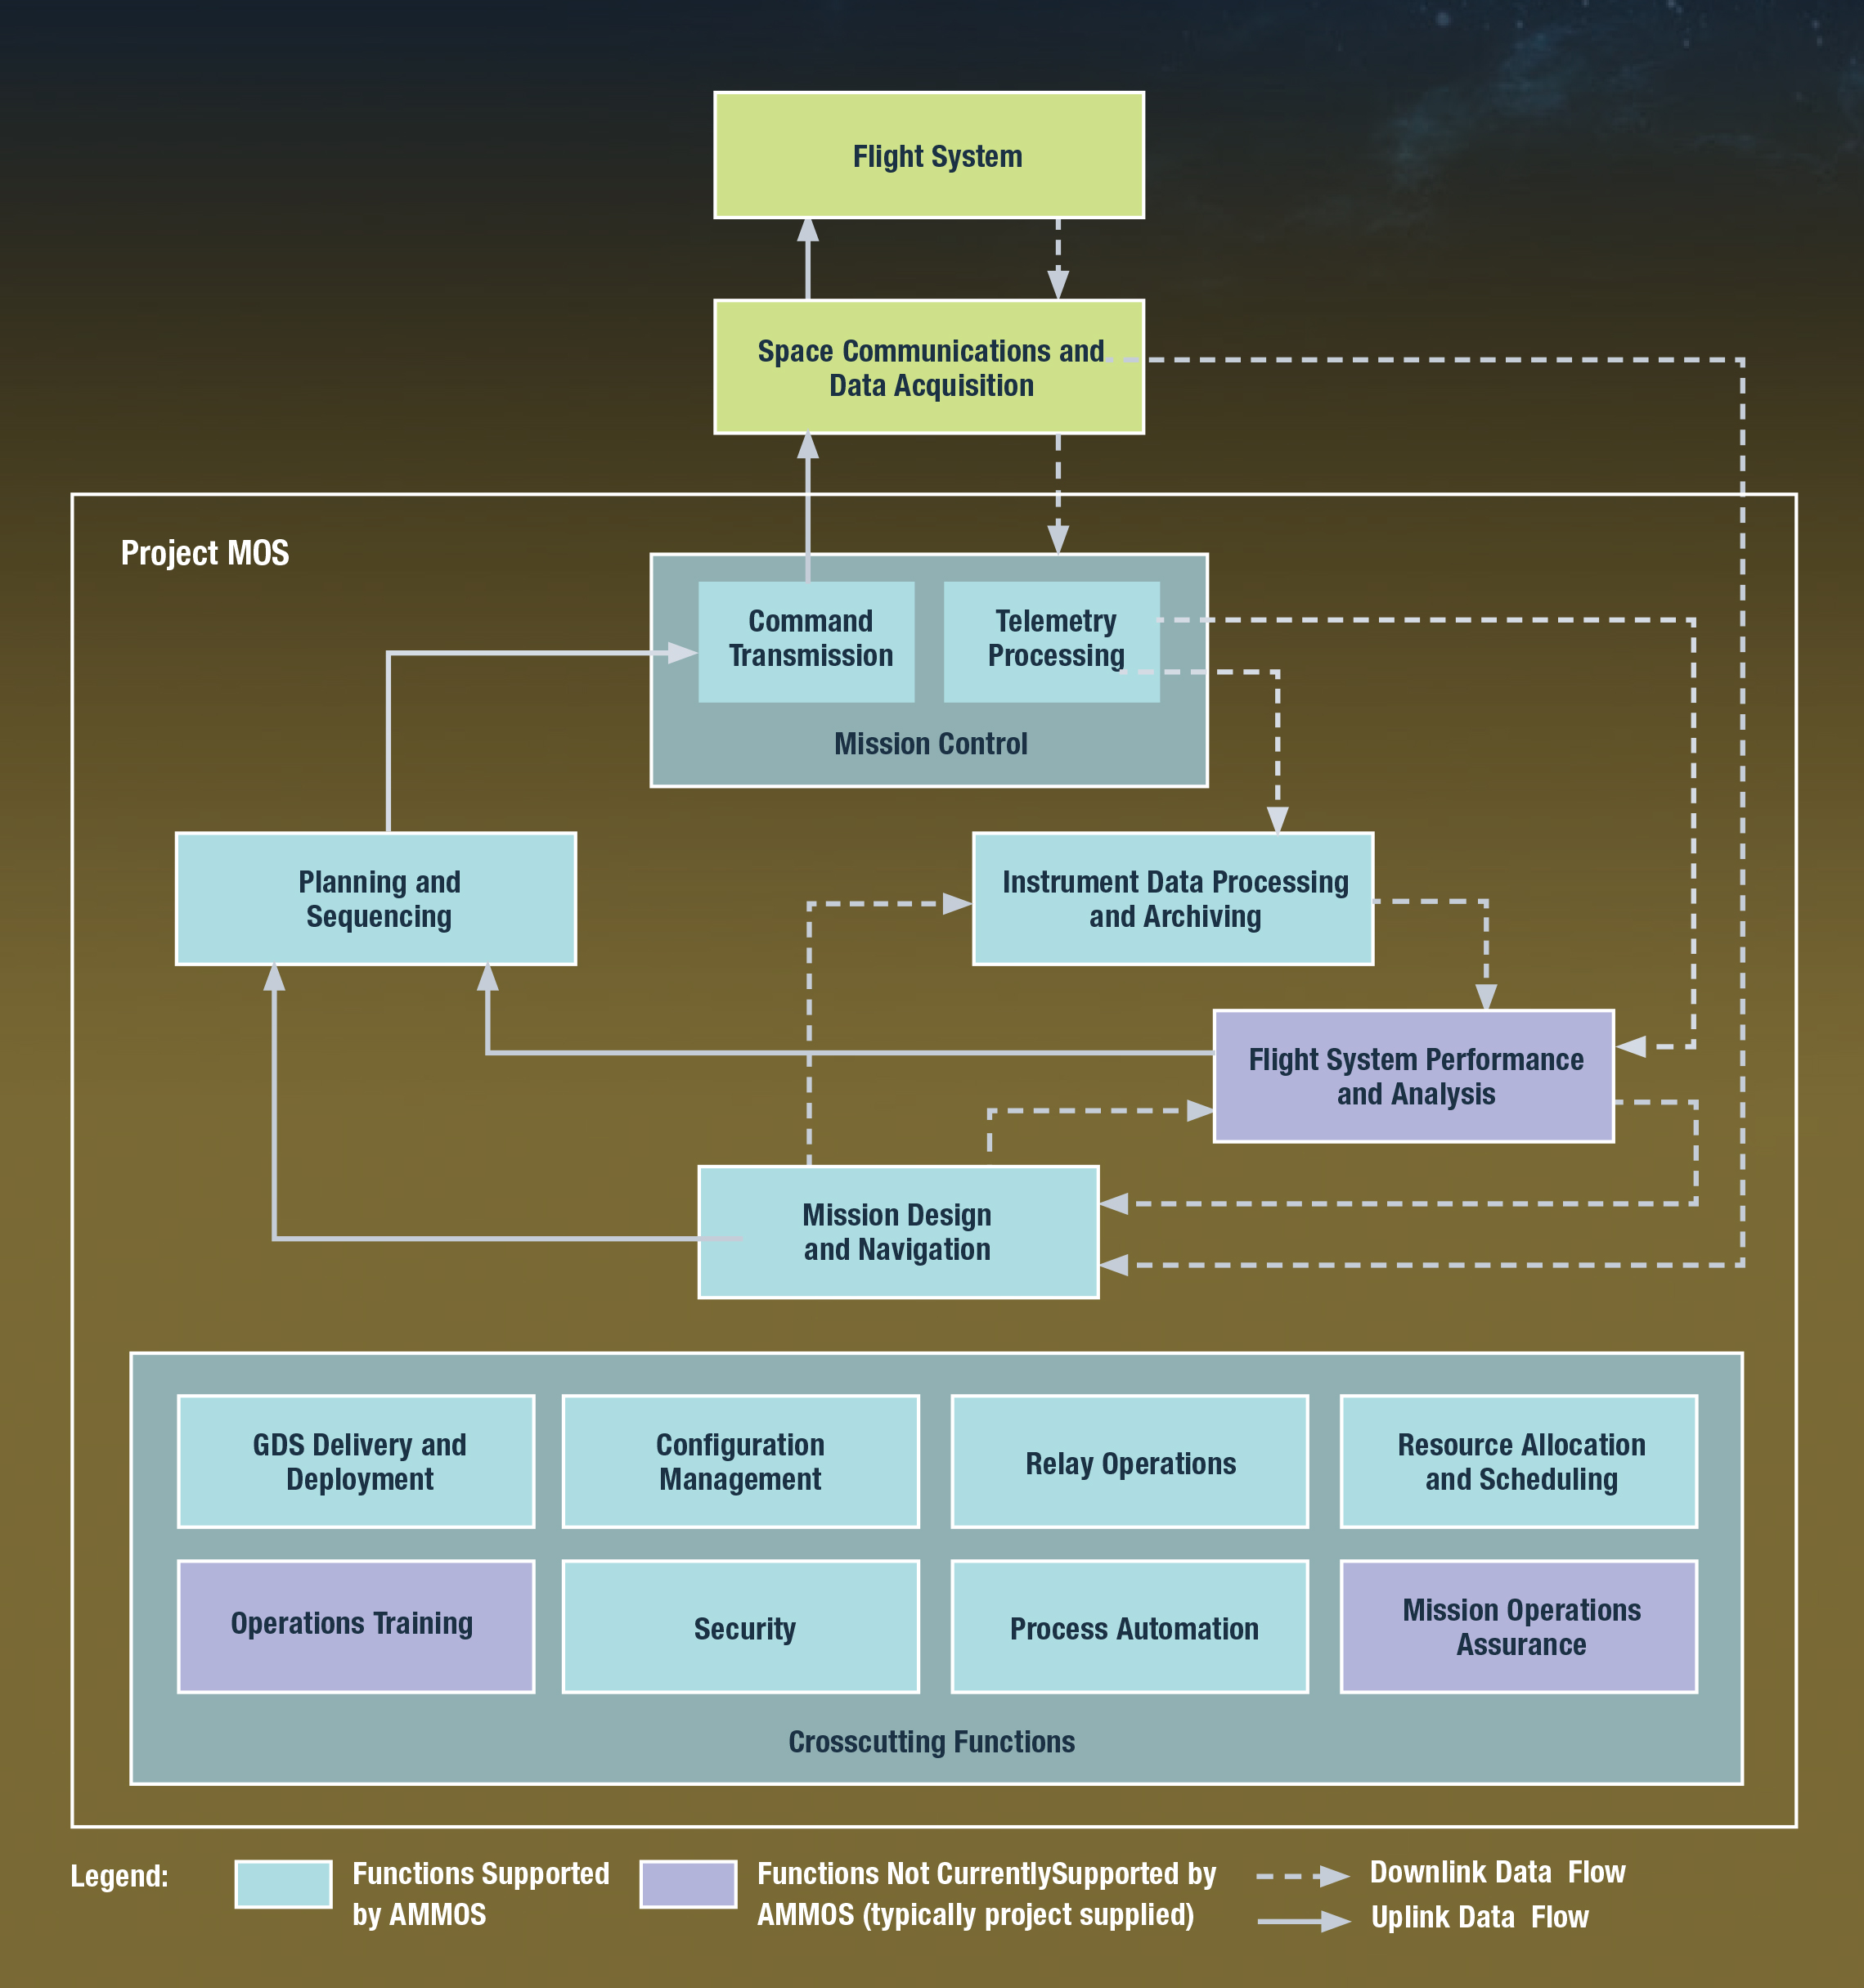

Figure 4 - Planning in the MOS Context

## Description of Current Activity Planning tool

The current AMMOS planning capability is provided by APGEN. APGEN has its own, integral UI which is shown in Figure 5. The most common way for a user to place an activity instance is to specify an absolute start time for the activity. APGEN provides the capability to schedule an activity instance based on temporal or dependency constraints with respect to other activities or events. This capability may be used, for example, to schedule default downlink activities during DSN tracking passes.

After simulating the resource effects of a plan at the activity level, APGEN determines whether the plan violates any activity level (e.g.,state requirements of an activity is not satisfied) or plan level constraints (e.g., power goes below minimum state of charge allowed).

APGEN (**A**ctivity **P**lan **Gen**erator) is a high-level planning tool that contains activity instances scheduled on a timeline. In addition to providing a GANTT-like timeline visualization of an activity plan, APGEN can also model the results of those activity instances on a spacecraft or an instrument. These results may be represented by a state (Heater A is ON or OFF); a numerical, non-interpolated value (Heater A is drawing 10 Watts of power); or a numerical, interpolated value (the battery state-of-charge falls from 20 amp-hours to 19.8 amp-hours while Heater A is ON).

Mission may wish to use the simulation and constraint checking capabilities of APGEN but not the graphical user interface of APGEN. APcore provides this capability through a communications engine. The communications engine is a server that a user can command through XML-RPC. Apart from replacing the user interface with the XML-RPC interface, the APcore interfaces are identical to those of APGEN described below.



Figure 5 - APGEN User Interface

## Description of The Current Sequence Validation Tool

SEQGEN (**SEQ**uence **GEN**erator) expands ground and on-board blocks into sequences, models command effects, and simulates command execution timeline, and validates integrated and stand-alone sequences against flight rules. The sequence expansion blocks and command models are defined in mission specific SEQGEN adaptation.

Input to SEQGEN is an SMF file that maps commands in a sequence to command effects. SEQGEN’s main output is a Predicted Events File (PEF) that describes command execution timeline, along with predicted spacecraft and instrument states, and resource profiles.

After it models the effects of sequences, SEQGEN determines whether the sequence violates Flight Rules or any other constraint identified by the mission. These Flight Rules are mission specific, but in general they enforce state or parameter constraints for a command, or relative timing, ordering constraints across commands.

SEQGEN does not enforce any structure to creating mission adaptations. For instance, MSL SEQGEN adaptation embedded Flight Rule checks within command models. Such that every time a command is called, its model is invoked and within that model all Flight Rules relating to that command was checked. This approach led to repeating same Flight Rule checking code in multiple places in the adaptation within the model of every command that relate to the Flight Rule. As a result, editing Flight Rules in MSL became a very challenging task due to repetition of code. InSight SEQGEN adaptation on the other hand, implemented a trigger-based software architecture, where Flight Rule checks were abstracted from command models. This led to decreasing structural dependence between otherwise independent models and rules. Also allowed for a robust model interface to define multi-mission (black-box) models.

SEQGEN does not include a direct user interface. Instead, it defines an XMLRPC/REST interface that other programs can use to access it and its full functionality. AMMOS provide the MSOP Scripts and MPS Editor as SEQGEN interfaces. Individual missions are welcome to use the REST API to call SEQGEN directly from their own tools.

## 

# Development and Execution Stages of A Mission

A mission goes through many stages, as summarized in Figure 6 below, before operations begin in Phase E. The software infrastructure that enables activity planning and sequencing and validation matures along this timeline before mission begins operations.

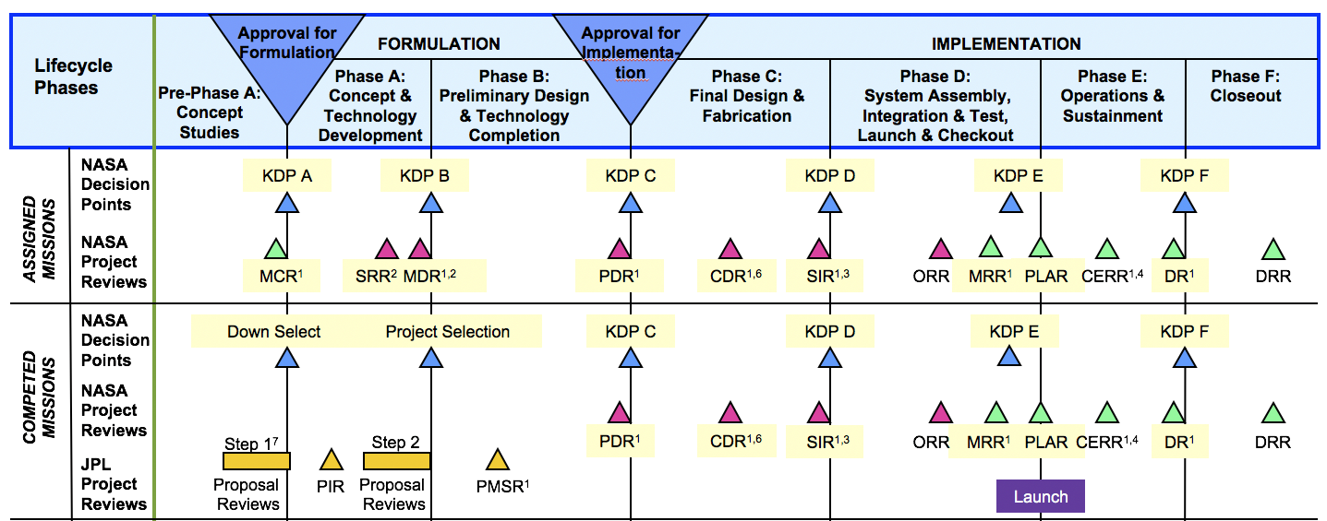

Figure 6 - Mission formulation and implementation phases. For abbreviations see:

<https://projectsupport.jpl.nasa.gov/life_cycle/nasa_jpl_reviews.cfm>

Assigned missions are strategic missions where mission target and basic goals are defined by NASA in a top-down approach. Their development and management are tightly controlled and their budget is significantly higher than competed missions. Competed missions on the other hand, are initiated by principal investigators responding to open-ended proposal calls. Their science goals are defined by the proposal team. In both cases a *science definition team* describes high level science objectives. The science definition team works out how the mission can achieve these science goals given a reference trajectory and strawman instrument definitions. Science definition team works with simplified spacecraft, instrument, trajectory models to do their analysis. At this stage the analysis focuses on estimated cost versus science return for the conceptual mission. The final product of this stage is the approval of Project Implementation Plan (PIP). Science definition team dissolves after PIP is approved. NASA then creates Announcement of Opportunities, to solicit science and engineering teams to create instruments that can achieve the described science objectives in the PIP. Through a process of evaluation of competing proposals, instrument teams are selected.

As the hardware specs and budget gets more solidified, mission designers create a more realistic integrated trajectory before Mission Design Review (MDR). Mission planners start evaluating a mission by asking questions of how much data return or how much surface coverage is possible given the integrated trajectory and instrument specs. As trajectory gets realistic more accurate cost estimation can be done more accurately this stage. In parallel, instrument teams start their design and formulation which can deviate from the strawman instruments previously described. For instance, while the strawman payload was body mounted, the solicited instrument may feature a gimbal. This difference and its implications for mission operations have to be analyzed by the mission planners. We will discuss the role of mission planners in more detail in the following section.

A mission goes through several development phases before its in-flight portion, Phase E, begins. Although actual Activity Planning and Sequencing takes places during phase E, the software tools that

enable Planning and Sequencing start forming and evolving much earlier.

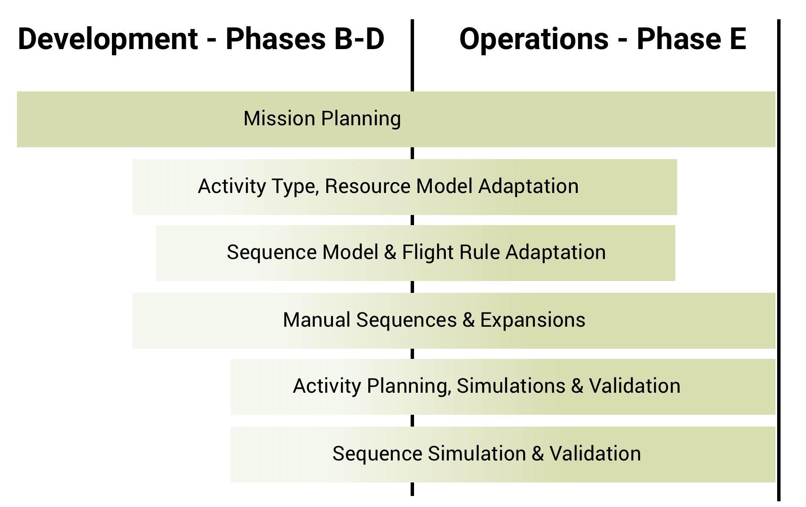

Figure 7 – Performed tasks during mission development and operations phases.

For instance, during development phases a Command Dictionary is developed along with models describing command behaviour and Flight Rules to observe while utilizing these commands. Similarly, Activity Type definition development begins earlier in the mission development phases. These two must be completed before operation phase begins, however, they can be continuously edited and refined throughout the mission.

Although the diagram in Figure 7 represents mission operations phase as a single block, there are three distinct phases within this period. During post-launch, missions with a cruise period perfom a version of planning and sequencing for longer execution periods, as the spacecraft is only executing activities like instrument check outs at a slow-paced cadence with no scientific observations. Early mission is generally the most critical portion of operations for a number of reasons. During this time, engineers must meticulously craft activity plans and sequences, comparatively analyse predicted models versus actual behaviour, all while their operations concepts, assumptions and instruments are being tested. During this period, many refinements are made, such as editing Flight Rules and Activity Models. Primary mission is where a nominal process for Planning and Sequencing is refined and further automated for efficiency. During this period models may continue to refine but at a much lower frequency.

Additionally, during the development phases, high level scientific goals and objectives for the mission are specified in a *Mission Plan*. Mission planning concentrates on developing an end-to-end representation of the entire mission, capturing critical events at a high level, as compared to the routine planning operations. The fidelity of this representation varies from mission to mission. Development and maintenance of the mission plan starts early in the mission, Phase A or Phase B, however the mission maintains and updates the plan until the end of the mission. The details of mission planning will be discussed in the next section.

## Mission Planning

As mission development progresses, more and more accurate information from various sub-systems and instrument teams becomes available. Mission planners gather all this data, translate them into models, and conduct scenario analysis to understand implications across sub-systems, instruments, operations and science goals. For instance, mission planners have to figure out how to accommodate real instruments which may be heavier, generate more data, or require more power than originally anticipated by integrating multiple design inputs from sub-systems and instrument teams. As Jan Ludwinski describes, mission planning is nothing more than juxtaposition of various data.

Our interest in mission planning work is emanating from mission planners’ interest in using adaptation frameworks to do their modeling and simulation work. If mission planners were to use the same adaptation framework that will be used in operations, as opposed to only using a readily available adaptation framework, it would save time for mission planners, but also it will allow the models created during mission planning phase to be re-used during operations.

However, the fidelity, level of detail, and abstraction of models created during mission planning vary significantly across missions. For instance, Mars 2020 mission planners ran a vast range of scenario analysis using Monte Carlo simulations, where hardware capabilities and landing site terrain properties were varied significantly in the models. Dealing with such a large problem space required them to simplify activity modeling at the sol level. This meant that instead of modeling individual activities that will be modeled during operations, mission planners modeled several sol types where certain groups of activities are conducted together, such as drive sol, drill sol, sample cache sol etc.

On the other end of the spectrum, Europa mission planners have a 4 year-long reference trajectory with about 400 flybys where majority of science data will be collected. Having a very definitive trajectory along with relatively well-defined hardware specs, allowed mission planners to create activity models at a comparable granularity level of models that will be used in operations. Even then not every resource is modeled at the same fidelity as it will be during operations. For instance, Europa mission planning adaptation created in APGEN features a very accurate GNC model which can be used in operations. However, the instrument activity models are still in progress.

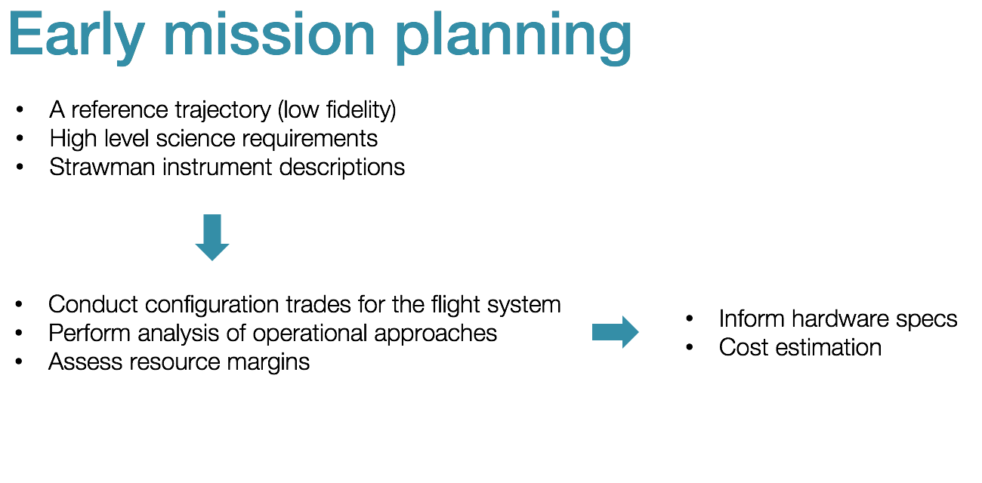 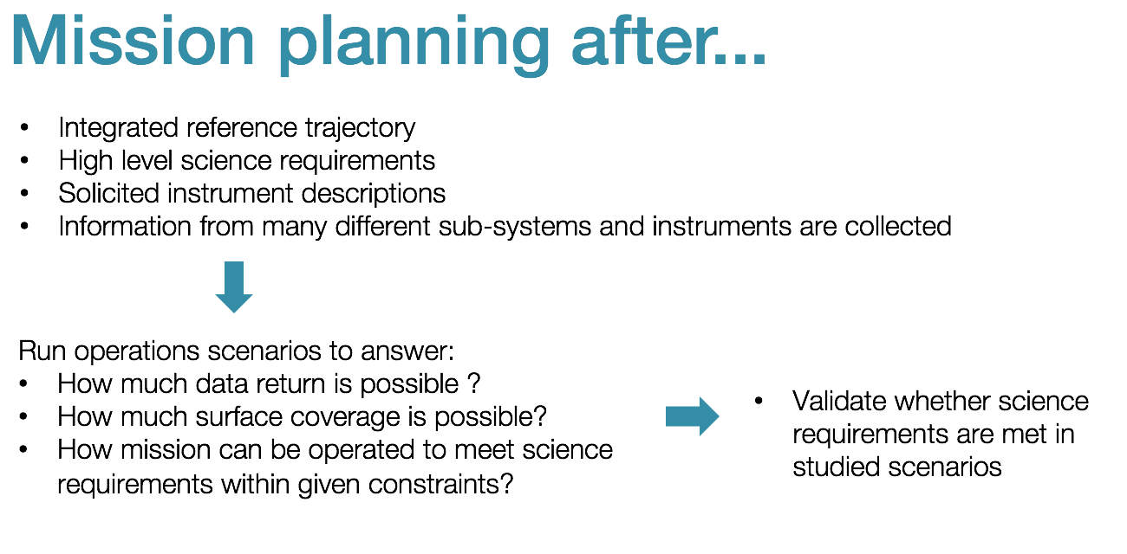

Figure 8 – Role of mission planning summary.

One of the key differences in using an adaptation during mission planning and operations is the frequency of modifications to adaptations. During operations, adaptations mature and remain steady for the most part. Exceptions occur when a piece of hardware degrades or loses a capability. Then models have to be updated to reflect these limitations. For instance, MER APGEN adaptation went through a major rework after long term memory on board was lost. Generally during operations a given plan is simulated as opposed to wide ranging scenarios being simulated during mission planning. On the other hand, during mission planning models not only evolve at a fast pace, multiple models are compared to inform hardware and operations design. Necessity to run and analyze many simulations require simplifying models to achieve reasonable performance.

As noted before, the wide-ranging scenario analysis performed during mission planning requires tweaking the adaptation frequently. Mission planners’ work is to decide which variable to vary and by how much in the models. Mission planners often create a configuration file that captures most frequently edited model parameters and settings. Being able to abstract parameters that need to be edited frequently is a highly desired feature for a modeling tool that can be adopted by mission planners.

Besides wholistic scenario analysis and trade studies for the whole mission, during mission planning key phases of a mission has to be planned out in detail. For instance, NISAR mission planners are tasked with creating and activity plan to ensure instrument checkouts can be completed within 90 days after launch. This type of activity planning is very similar to activity planning performed during operations phase of the mission.

To summarize, creating activity model adaptations and activity plans is a common task performed by mission planners long before mission operations begin. Mission planners may work with simplified or more abstracted activity models. Yet, these models will be tweaked frequently for comparative analysis to perform scenario or trade study analysis. Aerie adaptation framework and activity planning tools will be designed to satisfy the mission planning needs described above.

## Operations

During Active Mission, a well-defined process for creating activity plans and sequences is followed meticulously. Downlink data analysis closes the loop by informing the next planning cycle about execution success of the previous activity plan, as well as health and safety of the spacecraft.

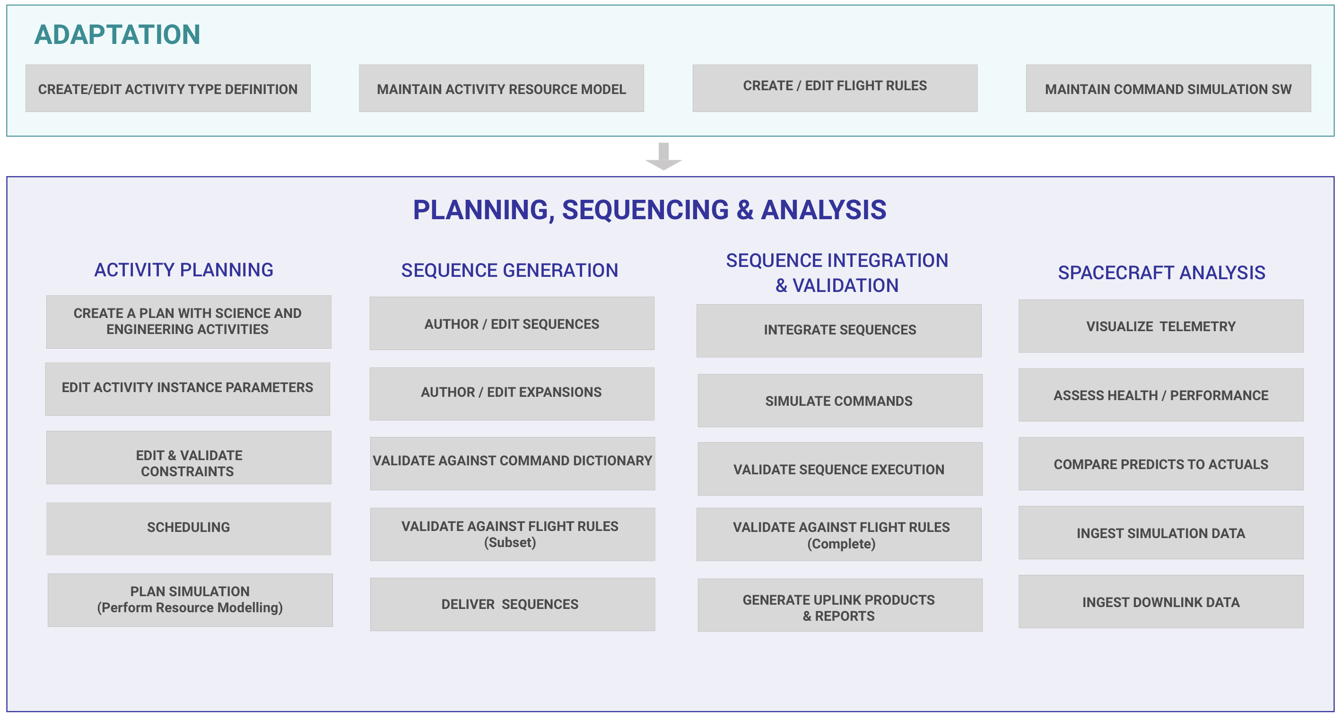

Figure 9 – Tasks performed during operations. While some of the tasks are performed by the scientists and engineers, more and more missions automate these steps.

Figure 9 above summarizes common tasks performed during activity planning, sequencing and spacecraft analysis stages of mission operations. Each of these steps will be discussed in detail in the remainder of the document. While we identified creating science and engineering activity instances, editing activity parameters, constraint checking and validation, scheduling and simulation as individual tasks, independence among these or a sequential order should not be assumed. For instance, scheduling can be automated with constraints, hence scheduling can ensure validity of constraints as in case of Mars 2020 mission. Similarly, activities can be instantiated based on constraints. More interestingly, scheduling may depend on simulation, where activities are scheduled based on resources estimated at the time of scheduling. Similar arguments can be made for sequences that are expanded automatically from activity instances. Parts of validation can be performed strategically even before a plan exists.

Stages of activity planning, sequencing and analysis can be summarized as follows:

* Create a plan with science and engineering activities – Specification of science observations and engineering activity instances to be performed within the planning period. Note that activities can be manually instantiated or logic for desired activities can be expressed in high level activity decompositions or scheduling constraints that will be discussed in Section 4.
* Edit activity instance parameters – Define how exactly an activity will be performed. For instance, specification of image resolution for a camera, or a specification of data bin that the data products will be stored in are all achieved by editing activity instance parameters.
* Editing and validating constraints – specify constraints that a final activity schedule must adhere to. Ordering, timing constraints for activity instances are common examples.
* Scheduling – assigning an absolute time or relative order for activity instances to be performed. This can be manually done by operators or can be automated based on input constraints.
* Plan simulation – simulating resource models for a given schedule and initial conditions to estimate resource consumption and keep track of key states. Simulation results are then used to validate some constraints that depend on resources and states.
* Author sequences – Manually create sequences that implements an activity in the plan. Some sequences may not be represented in an activity plan.
* Author expansions – Define an algorithmic logic to derive a sequence that implements an activity instance based on its parameters.
* Validate against command dictionary – validate a sequence contains valid command stems with allowed parameter types and ranges.
* Integrate sequences – Generate a master / backbone / background sequence that calls other activity sequences. Note that not all sequences have to be integrated.
* Simulate command execution – Emulate hardware on the ground to derive an order of execution for commands in sequences, while tracking spacecraft state.
* Validate flight rules – ensure sequences comply with flight rules that are enforced on the ground.
* Generate uplink products and reports – create binary products ready to be uplinked to the spacecraft, along with reports documenting their contents and intent.
* Visualize telemetry – visualize EHA, EVR data that record events and state on the spacecraft as sequences are executed.
* Assess health and performance – automatically check pre-defined rules such as EHA alarm ranges or alarm EVRs, diagnose root cause.
* Compare predicts to actuals – compare simulation data to as run data to assess performance.

Many missions work on strategic plans long before the planning period described above begins. There are two levels of long-term planning that happen beforehand and inform the planning period described above. The first one is the *mission level planning*, where the overall science objectives of the mission are described at a high level. Then these goals are divided into smaller chunks to formulate *strategic plans* that often list and prioritize science observations for multiple plan periods ahead. These types of activity planning often do not involve simulating actual plans.

Note that activity planning is canonically a precursor to the sequencing stage, where activities serve as abstractions of sequences that will be performed by the spacecraft. Activities are ground constructs that spacecraft has no knowledge of. Activities are for simplifying a plan for humans and simulation tools. Some missions may omit the activity planning stage if their planning process is more automated, or if there is no room for considering alternative sequence timings or orderings. A more modern approach is to more tightly couple activity planning and sequencing operations, such that a valid activity plan should automatically map to a valid sequence plan. More discussion on this approach can be found in Section 6.

### Roles involved in Planning and Sequencing

The following are the common roles identified in the operations scenarios described in the following sub sections. Not every scenario applies to every mission, nor is every role performed during every mission operation. A mission may also combine two or more of these roles into one position, or split them into multiple roles if necessary. Also note that missions often use their own terminology to name the roles described below.

* **Science Team Member** – Responsible for developing and maintaining activity type definitions for science activities. Responsible for developing instances of science activities to be included in specific activity plans.
* **Instrument Scientist** – Responsible for the design of the instrument to meet the scientific observation goals. Develops and maintains activity types describing of how the instrument can be operated to achieve a specific observation.
* **Instrument Engineer** – Responsible for developing and maintaining activity type definitions for instrument engineering activities. Responsible for maintaining activity instances in the plan to ensure they meet the science intent and engineering safety goals. Responsible for delivering valid sequences that implement corresponding activities in the plan. Also responsible for analysing downlink data to assess health and safety of the instrument.
* **Subsystem Engineer** – Responsible for developing and maintaining activity type definitions for Spacecraft subsystem engineering activities. Responsible for maintaining subsystem engineering activities in the plan to ensure they meet engineering intent. Responsible for delivering valid sequences that implement corresponding activities in the plan. Also responsible from analysing downlink data to assess health and safety of the sub-system.
* **Spacecraft Systems Engineer** – Responsible for ensuring the overall safety of the spacecraft based on input from all instrument and sub-system engineers. Performs more of a downlink assessment role in determining whether the spacecraft is in a healthy state as predicted from the previous execution period. Also responsible from analysing downlink data to assess health and safety of the overall spacecraft.
* **Activity Planner** – A liaison between science and engineering responsible for integrating activity instances into a valid activity plan that meets both science intent and engineering goals. Responsible for analysing differences between the predicted effects of an activity plan and the actual flight system behaviour.
* **Payload / Instrument Lead** – A representative of the instrument who is final authority to make final edits to the instrument activities in the plan. This role is only common in missions where planning is performed frequently or daily.
* **Sequence Integration Engineer** – Responsible for creating a valid sequence plan from delivered engineering and science sequences and commands.
* **Uplink Lead** – Approves sequences that will be radiated to the spacecraft. Responsible for approving waivers for violations allowed in the sequences. This role is only common in missions where planning is performed frequently or daily.
* **Mission Manager** – Keeper of mission level science goals and metrics. Responsible for approving waivers for critical violations allowed in the sequences.

### Simplified Planning Workflow

As mentioned earlier, a nominal planning and sequencing process starts with science and engineering team members creating a timeline that schedules all required science and engineering activities and eliminating all activity level or plan level constraint violations. The main input for this stage is a well-defined list of activity types that they can choose from. These activity types are units in planning that help operators to communicate and predict spacecraft behaviour at a high level. There are many variations across missions regarding how activity types are defined, how activity instances are created in a plan, and how they are scheduled.

The second stage is the sequencing stage, where activities described in the plan are translated into commands and sequences. Again, there are significant differences between missions regarding how sequences are generated.

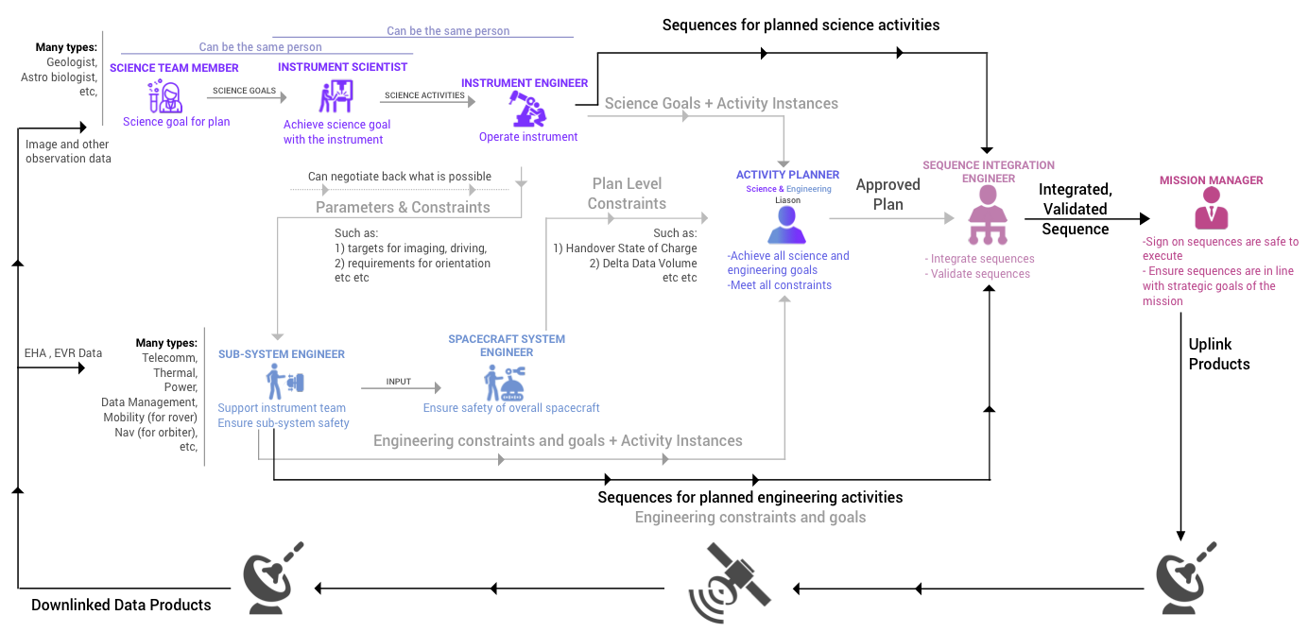

Figure 10 – A simplified nominal process diagram during a planning and sequencing period. Grey lines can be omitted in some missions.

Figure 10 above describes a very simplified mission operations workflow. In summary, requests for scientific observations comes from scientists. Instrument scientists and engineers define activities that can achieve observations with given instruments. Engineering operations also plan activities to ensure spacecraft health and safety, to manage telecommunication with ground, and to support science activities. For instance, thermal sub-system has to ensure all instruments will be warmed up prior to use. Similarly, navigation team members have to ensure pointing necessary for certain observations.

In some missions an integrated science and engineering activity plan is produced. Some missions may skip this stage, and keep science and engineering planning completely independent of each other. In certain missions engineering planning can be completely automated, hence engineering activity planning can be skipped altogether. Sequences are commonly integrated into background, or master sequences which are then validated against flight rules. Finally, uplink products ready to be radiated are generated, along with reports documenting their content and intent. Downlink operations closes the loop by providing input to the next planning cycle. Along the nominal process described above we observed more variations in activity planning and downlink analysis portion, and less variations in sequencing portion. The details of these variations are discussed in Sections 5, 6 and 7.

# Mission Adaptations

## Development of Mission Adaptations

Each mission has unique concerns regarding resources and interactions between different pieces of hardware. Missions perform activity planning and simulation to be able to estimate resource consumptions and to detect constraint violations early in the process. For instance, Flight Software may not allow executing certain commands in parallel. In order to detect such failures early in the process, these restrictions are translated into constraints for activities that involve these commands. During activity plan simulations, all such constraints are validated.

Most adaptations model activity durations, power load and consumption, data accumulation and downlink volumes. Yet, MRO APGEN adaptation models neither power nor accumulated data volume since both resources were considered not restricted. On the other hand, necessity to track various spacecraft states increases when there is more dependency or shared resources across different hardware. For instance, when scheduling body mounted instrument activities, spacecraft pointing has to be considered. Whereas instruments that feature a gimbal can be independent of spacecraft pointing, hence won’t require a pointing model. Similarly, a spacecraft that features solar panels and eclipsed long durations will need to track sun pointing and battery state of charge carefully as in the case of Juno.

In short, a mission adaptation consists of resource models that needs to be tracked, and activity type definitions that describe activities’ effects on these resources.

Missions create adaptations over a period with resource models and activity types evolving over time. During implementation phases of the mission, both mission planners and operations engineers create adaptations with inputs from instrument and sub-system teams. The level of fidelity and granularity of adaptations increase over time as software and hardware simulations gather more and more data about hardware behaviour.

While hardware is being designed and developed, adaptations are updated very frequently as discussed in Section 3.1. During operations, models can be refined further as missions gather *‘as run’* data from the spacecraft. However, frequency of these updates slows down significantly as mission progresses.

Traditionally, APGEN is used to create Activity Model adaptations. APGEN is written in a domain-specific language (DSL) which introduces challenges in training developers, maintaining the code base, and performance of simulations. If well designed, DSLs can be powerful in simplifying and reducing amount of code that needs to be written. DSL allows users to define “what needs to be done”, hiding the “how” portions of the code. However, designing DSL with careful considerations for performance is a diminishing skill. More importantly, necessity to parse DSL into a language that can be compiled introduces significant performance bottleneck. Hence, Aerie is going to use Java as adaptation framework language to avoid the performance bottlenecks. In the following sub-sections we describe common or desired attributes for mission adaptations.

## Format

As noted earlier APGEN is traditionally used to create activity and resource model adaptations for many missions. However, missions with simple modeling and simulation needs can store activity types in an Activity Dictionary, as in the case of MSL. Activity dictionaries are often XML like hierarchic data structures, and can encode simple effects in the form of regular expressions. For missions that rely solely on an activity dictionary, the Activity Planning tool handles resource modeling by simply integrating resource effects over time for a given schedule. Note that in such missions, scheduling is a manual affair to a great extent.

What can be expressed in an Activity Dictionary is very limited. Resource effects for activities are limited to regular expressions. Missions that require Turing complete resource effect models have to use APGEN or a similar adaptation framework. Moreover, interpreting and computing these expressions during planning would impose significant performance challenges to missions that deal with longer planning periods with many more activity instances compared to MSL.

Activity Dictionaries are very structured. It is relatively easy to edit and validate them. Hence, an Activity Dictionary is more accessible to a larger audience to define new activity types or edit existing ones as opposed to creating or editing activity types in an adaptation code. Europa Clipper mission is intending to create an activity / resource adaptation using Java based adaptation framework of Merlin (Aerie planning tool). But at the same time, the mission is planning to define activity types in a dictionary to make it more accessible to scientists and engineers who are not expected to read and write adaptation code. Aerie tools should support missions to keep working with Activity Dictionary constructs.

## Activity Types

An Activity Type is an abstracted description of a science or engineering task that will be performed by the spacecraft. An Activity Type is a unit for planning and/or modeling which helps operators understand and predict the effects of an activity at a coarse level. Activity Type generally consists of the following four parts:

1. **parameters** that describe how an activity can vary for modeling and commanding purposes,
2. **constraints,** which are requirements for safe execution of the activity, and they enable detection of resource and state violations in an activity plan, and
3. **effects** on various spacecraft resources and states which are often expressed as algorithms, formulas or expressions involving parameters, attributes and constants,
4. **decomposition**, logic describing how an activity can be broken down into other activity types.

Parameters define the boundaries of how an activity can vary in a plan. Allowed units, ranges and default values for parameters are defined in Activity Type definition.

There are many constraint types ranging from temporal constraints such as ‘activity must execute between Time 1 and Time 2’, or geometric constraints such as ‘the solar angle must be between Angle 1 and Angle 2’. A constraint can enforce ordering such as ‘must be preceded by Activity Type 1’, or can be based on spacecraft state, such as ‘cannot occur when this piece of equipment is on’. While some constraints are defined at the adaptation level (in other words, must be true for all instances), others, such as timing requirements can be edited at the activity instance level.

Effects can be static – the same for all instances of that type – or dynamic – calculated based on instance parameters or the state of the flight or ground system. An effect can sustain throughout the duration of the activity, or it may only take place at the beginning or end of an activity. A state effect typically occurs instantaneously. A resource effect can occur instantaneously or over a period of time.

An activity type which is a token for planning for operators, might be **decomposed** into smaller activity chunks that repeat in multiple activities to simplify modeling. For instance, an *Instrument On* activity is defined once with its behaviour model as an activity type, and is nested under every activity type of the same instrument which allows using the same model for turning on the instrument across all the instrument activities. Hence many activities that operators interact with during planning can be decomposed into a set of linearly staggered activities that are units for modeling and simulation.

Furthermore, some missions may develop deeper hierarchies, by combining these activity types into logical groups that achieve more complicated tasks. While effects are not defined at the activity group level, requirements might be defined at the activity group level. Figure 11 below shows the nesting of Activity Types described above. These activity groups can be defined in the context of a plan, or some may be defined as activity decomposition in an activity dictionary or adaptation. This type of decomposition is called a non-exclusive decomposition in the legacy APGEN tool.

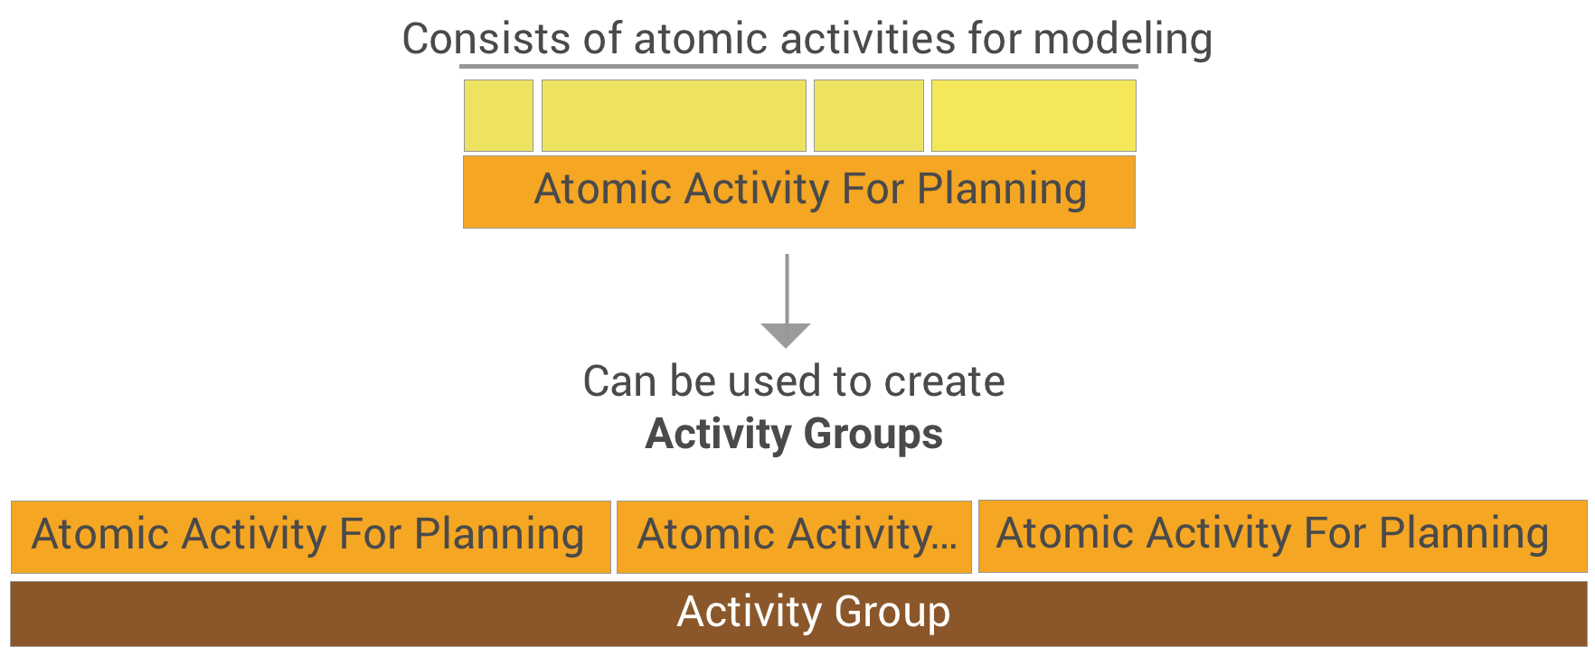

Figure 11 – Activity Group decomposition

Activities can also describe a **scheduling decomposition** for independent activities in the plan. For instance, a single activity can be responsible from interpreting DSN allocation file and scheduling individual telecommunication activities at each communication window with parameters assigned algorithmically. Another example for such a decomposition is an activity ensuring spacecraft state before it’s execution. For instance, an observation that requires specific pointing can describe how to schedule maneuver activities before itself in its decomposition. This is called exclusive decomposition in the legacy APGEN tool. Note that when activities are decomposed in such a fashion, modeling of parent activity is independent of the children activities.

During our interviews and subsequent software reviews with various missions, we observed variations in how activity types are defined and maintained. These variations are summarized as follows:

### Completeness for Commanding

Completeness for commanding indicates whether an activity type describes all parameters necessary for a sequence to be generated from an activity instance in the plan. If sequence engineers have to consult scientists, or provide input beyond what is in the activity instance, then the activity cannot be considered complete for commanding. Note that many missions use simple placeholder activities, where the specifics of what will be performed by the spacecraft is only specified at the sequence level. Conversely, many modern missions lean towards completeness for commanding for activities, where a sequence can be automatically generated solely based on parameters provided in the activity instance.

### Granularity of Activities

As noted earlier activities can be at various granularity levels. Mission planners can work with highly abstracted activities involving many instruments. Whereas, during operations missions can create atomic activities that map to a single command. Hence, granularity of activity types can increase over time. Note that, even if there will be atomic activities at the granularity level of commands for modeling purposes, planning will be performed with higher level parent activities to simplify the task for humans.

### Fidelity of Activity Effect Models

As noted earlier, activity models help operators characterize activity behaviour and its effect on spacecraft resources. However, the reliability of this activity level simulation depends on the fidelity of r models described in the Activity Type. For instance, one model can simply calculate power usage of an activity type by multiplying its duration with average power load. On the other hand, another model can produce a more accurate power load profile over the duration of activity. An activity model can simply define a delta effect on resources and states. Similarly, for state effects an activity can aggregate effects of all commands associated with the activity over the whole duration of activity, even though the commands take place over a small duration relative to the activity duration. More accurate modeling would require having atomic activities that map to a single command, such that state can be more accurately simulated.

## Mission Specific and Common State/Resource Models

As noted earlier each mission has unique concerns and restrictions about their spacecraft and operations. Hence, an adaptation framework should be flexible to simulate and keep track of any resource or state that mission operators care about. For instance, Europa Clipper adaptation has to feature a highly complex radiation model, which is not applicable to many other missions. Similarly, Psyche mission, which will orbit an asteroid of metal composition, will require a mission specific magnetic field model.

That being said, there are commonly shared limitations and concerns. For instance, power load, energy consumption, data volume and duration are the common resources simulated in almost every adaptation. Moreover, the ownership of certain models should lie with the domain experts rather than mission operators. For instance, geometry, attitude and pointing models can be shared across many missions, and should be owned by Navigation team experts. Similarly, a Ground Station model would apply to many missions who communicate through DSN and should be owned by DSN experts. Hence, providing black-box multi-mission models is considered a significant design driver for Aerie.

Similar to activity effect models, resource/state models can be in various fidelity levels. During operations different fidelity models can be used at different stages of planning. For instance, in MSL, MSlice tool provided a low fidelity power modeling for a crude estimation to guide planning. When the activity plan reached a certain maturity stage, planners ran MMPAT for higher fidelity power modeling.

In addition to common models, mission may wish to use external simulation tools, such as MMPAT being widely used for power modeling. Aerie should interface with common simulation software. Missions should be able to add interfaces necessary for any simulation tool.

The modelled resources / states in an adaptation can be finite, enumerated, or infinite quantities. They can be claimable or depletable, or can require restrictive increments. For instance, usage of robotic arm would be a claimable resource, while fuel would be depletable resource. Spacecraft state is often modelled as enumerations. A multi-mission adaptation framework should support modeling all such entities.

## Model Orchestration And Simulation

One of the key concepts in adaptations is the orchestration of models. In the simplest scenario, simulation can be performed after a schedule is finalized. If the resource models are independent of each other, the problem simplifies even further. Such that, given a timeline of activity instances, each model integrates effects over time independently. The models can run in parallel or in a sequential order. This type of simulation would suffice Mars surface missions like MSL. However, for other missions, models may have dependency on each other. In such cases simulation integration should progress models in small increments where state of each model can be communicated to dependent models during simulation progression. Furthermore, scheduling may depend on resource states in some cases. In that case, simulation and scheduling has to be orchestrated to progress in coordination. In APGEN this dependency of scheduling on resource states is referred to as ‘*OK To Schedule’,* meaning that scheduling has to inquire resource states to proceed with scheduling. After scheduling is complete, simulation has to be updated to consider the effects of the newly scheduled activity. Providing a flexible, multi-mission simulation orchestration capability is one of the key drivers for the Aerie architecture design.

Every simulation run starts with an INCON file describing initial conditions of states and resources to be tracked. During operations, the final conditions of these states, so called FINCON, can be fed as an INCON to the next planning cycle. To be able to simulate a portion of the plan, the resource and states should be captured at any desired point in the simulation, so that this data can be fed as an intermediary INCON.

## Scheduling

While some missions may rely on manual scheduling for majority of activities in a plan, some activity types have to be scheduled in an automated fashion. For instance, communication activities that are driven by DSN allocation windows (or in case of Mars surface missions, driven by approved view periods identified in MAROS) have to be scheduled automatically. In fact, scheduling of most engineering activities can be automated. Traditionally in APGEN, scheduling logic for such activities are captured in the decomposition logic of a higher-level activity. Details of scheduling logic decomposition is discussed earlier.

Orbiter missions dealing with long planning periods automate both science and engineering activity scheduling by describing a scheduling logic in their adaptations. The scheduling logic is nothing but a series of constraints describing frequency and conditions for when an activity can be scheduled. Mars 2020 mission, although working with an on-board scheduler, also describes scheduling logic with temporal constraints per activity, and dependency constraints across activities. We generalize all the listed approaches as constraint-based scheduling and plan to provide such constraint-based scheduling support in Aerie.

While inputs to scheduling algorithm can be described as constraints, the algorithm that handles the scheduling is another open question. Aerie is going to provide a discrete event scheduler, as well as a more advanced search-based scheduling algorithm. However, missions should be able to implement their own scheduling algorithm.

## Defining, checking Constraints & Opportunity Window Detection

Another primary functionality that an adaptation is to define and validate constraints. Constraints are rules that describe conditions for safe execution for activities, or the overall plan. These types of constraints are generally defined against spacecraft resources or state. In case of constraint-based scheduling, many constraints are inputs to scheduling. These are generally timing, ordering or dependency constraints across activities. Constraints can be defined for activity types, activity instances or a plan. Below is a summary of constraint types and corresponding examples:

1. **Temporal constraints**‘Activity Instance X can be performed between 9am to 2pm’
2. **Ordering constraints** ‘Activity Instance X can be performed after Activity Instance Y completes’
3. **Frequency constraints** ‘Plan should have three instances of Activity Type X’
4. **Geometric constraints** ‘Activity Type X can be performed when spacecraft is nadir pointing’
5. **Resource constraints** ‘Activity Type X can be performed only when state = value’
6. **Global constraints** ‘Maximum power load cannot exceed certain value’
7. **Composite constraints** ‘Plan should have three instances of Activity Type X’ **AND** ‘Activity Type X can be performed when spacecraft altitude is within range =[a,b]’ .

Composite constraints should allow chaining constraints with logical operators. For a given schedule all constraints must be validated. Note that, in case of constraint-based scheduling, scheduling constraints won’t be violated by the output schedule. On the other hand, identifying opportunity windows for activities, where all constraints are satisfied, is a pre-requisite to this type of scheduling. Even in case of automated scheduling, missions may define a set of ‘soft’ constraints that do not drive scheduling, but nevertheless should be checked. For instance, a mission may want to enforce a handover state of charge constraint that scheduler is unaware of, but has to be ensured by the operators. Moreover, missions may wish to start off with an automated schedule, but continue refining a plan by manually editing the activity schedule. In such a scenario, constraints should be validated against the schedule constantly. The same opportunity window detection mechanism used for automated scheduling can be used to assist manual scheduling as discussed in Section 5.6.

## Ownership and Collaboration

Ownership of activity model adaptations differ across missions but generally depends on the complexity of activity types. In missions where activities are required to be complete for commanding, and must have high-fidelity effect models, multiple roles take part in developing a single activity type, including scientists, instrument, sub-system and spacecraft engineers. Each party contributes to a different aspect of the activity type definition. Nevertheless, there is often a single authority who approves activity types to ensure that the activity types are validated and safe to be used in operations. In other missions where activity types are loosely defined and mostly serve a placeholder purpose, less coordination and validation are needed to create a new activity type.

## Versioning

Missions may also vary in their approach to version control their activity dictionaries or adaptations. All missions should version control the “active” version of the activity type definitions to be used during operations. A mission could implement this version control with a software version control system, such as GitHub, or a document control system, such as Docushare, or a dictionary control system, such as Helix, or even a mission-specific system. A mission might manage inputs into this system in different ways. On a team where definition responsibility is dispersed, subsystem experts may submit individual activity type definitions to an integrator who updates the operations version. The subsystem experts may modify, create new or edit existing activity types in a sand box, and then they can draft for review. A small, dedicated team, would then review, approve and merge new edits to be part of operations version.

Activity Types can be versioned individually at an atomic level or as a collection. Even if Activity Types are versioned individually, planning tools need to locate a bundle of Activity Types where all desired versions are available.

A mission creates and edits *Activity Model adaptations* throughout many phases of the mission. Depending on complexity of activity types, a mission may define a few or many activity types in the early development phases. The most intense period for activity type definition is during Phase D, leading up to Operations Readiness Tests (ORTs) and launch. It is during this time that the activity types intended for flight operations have to be verified. Updates to existing definitions and the addition of new types occurs in Phase E, during active mission, as missions learn more about how to operate their spacecraft.

As Activity Dictionaries or Adaptations are being developed, tested and released, multiple Activity Type definitions might be in circulation at any point in time. Also, missions might have overlapping planning periods each of which using a different version of the Activity Type definitions.

## Roles Involved

Given the variations described above, stating that roles involved in activity type definitions will depend on the complexity of these constructs is a straightforward conclusion. However, it is safe to assume that Scientists, instrument scientists, sub-system engineers who play active role in planning will drive creation of new activity types. However, effects of activity types have to be defined by sub-system and spacecraft experts who understands the hardware in great detail. Ownership and verification of activity type definitions will be highly mission specific.

## Command Models and Sequence Adaptations

Missions also simulate the sequences that implement the activity plan using adaptations. Which state/resources are modelled in a sequence adaptation is highly mission specific and tightly coupled with what is being covered in an activity adaptation. For instance, if a mission is modeling power usage at the activity level, may wish to not replicate the same at the command level. Sequence adaptations are often used to validate Flight Rules related to command invocations. Certain Flight Rules may depend on spacecraft state, hence sequence adaptation has to model all such states. Aerie is aiming to unify command and activity adaptation frameworks and allow missions.

## Summary of Capabilities Needed

Main capabilities of an adaptation can be summarized as:

* **Allow defining Turing complete resource models.**
* **Allow defining activity types with resource effect models, parameters and constraints.**
* **Define activity type schema** – Allow missions to describe their activity types in a dictionary, abstracted from the adaptation in a JSON or XML format, which can be a resource for the adaptation.
* **Allow adding new activity type** – Create a definition of a new activity type with name, units, types, valid ranges and default values in an Activity Type collection or dictionary.
* **Allow defining activity group decomposition** – Create a parent activity that consists of multiple children activities.
* **Allow defining schedule decomposition** – Define scheduling logic for activities to be instantiated and scheduled according to resources and states.
* **Allow modifying activity type definitions** – Modify an existing definition.
* **Provide a flexible infrastructure to orchestrate models and scheduling.**
* **Allow defining global resource and scheduling constraints.**
* **Provide an automated scheduling algorithm that adheres to resource and scheduling constraints.**
* **Detect and report constraint violations.**
* **Provide opportunity window detection** – where all constraints for an activity instance or type are met.
* **Allow users to import external resources** – such as geometry, DSN allocation such that resource and scheduling constraints can be defined against**.**
* **Track and record state and resource profiles along a simulation** – allow users to capture results at any intermediary step of the simulation.
* **Ingest and INCON** – that describes initial conditions for states and resources to be tracked.
* **Generate a FINCON** – that describes final conditionsof states and resources that are tracked.
* **Support simulating a subset of an activity plan** – Allow operators to simulate critical portions of a plan more frequently rather than the whole plan.
* **Manage activity / resource adaptation versions** – Allow versioning of adaptations, allow operators to switch between adaptation versions.
* **Collaboration and permissions** – Restrict access to operations version of an adaptation.

# Activity Planning

An activity plan is a collection of activity instances that are scheduled to be executed during a duration that spans a mission’s planning period – a local day, an Earth week, an orbit, or whatever else a mission determines to be the natural cadence for commanding its spacecraft. A valid plan is one in which all of the required activity instances are scheduled and no plan level or activity level constraint is violated. Note that while some constraints can be defined at the Activity Type level, some requirements for an activity, such as the temporal constraints that restrict execution time, can be specified or edited within the context of a plan. Instead of atomic level activities, a plan can use Activity Groups that are defined as an Activity Type or can form Activity Groups within the context of a plan.

Generally, science activities in the plan are handled as part of ***Science Planning***, and engineering activities are handled as part of ***Engineering Planning***.

**Science Planning** refers to thegeneration and editing of activity instances in the plan that map to a specific scientific observation. A science activity generally involves a specific instrument, however more complicated activity groups can involve multiple instruments. Editing a science activity instance in the plan might require having contextual information about engineering activities contained in the plan or the spacecraft state during the execution of this activity. More specifically the information needed might include:

* Visual representation of the area or volume being measured, which is often referred to as *instrument footprint;*
* Geometric conditions including terrain, lighting, altitude;
* What other activities are scheduled at the same time or on the same target location;

How much of this information is available to a science team member depends on a mission’s planning process and adopted collaboration process between Science and Engineering teams which discussed in Section 5.8.

The science planning is informed by strategic level plans created beforehand, which sets long-range science objectives based on the overall Mission Plan. How this information flows from strategic plans to the actual plan as science intent for the plan is often handled internally by the science team, and is not supported by the planning tools, so it is out of scope for this document.

**Engineering Planning** refers to generation and editing of engineering activity instances in the plan, however, in many ways, is simpler than Science Planning. Engineering activity types tend to be more utilitarian, and are performed more routinely, as in the case instrument health check outs. Other engineering activities can be instantiated and scheduled in an algorithmic way. For instance, telecom activities for a mission are automatically generated based on the DSN allocation file.

A subset of engineering activities can be highly complex, for instance a maneuver or a drill to be performed with the robotic arm. These activities are often represented with low fidelity placeholder activities in the plan, or handled as a special case outside of the activity planning process altogether.

Beyond creating science and engineering activity instances, a plan generally has a set of plan level constraints such as *Handover State of Charge*, *Delta Data Volume* that can be generated or *Delta Spacecraft State,* or the *Handover State of Charge* aimed at the end of plan execution. There are other plan level constraints that generally remain the same across plans such as the *Minimum State of Charge*, *Maximum Power Load* allowed throughout the plan.

In a simplified overview, Activity Planning implies instantiating, editing and scheduling activity instances. Finally, violations must be resolved and constraints must be satisfied, which requires editing schedule and activities further. Activity Planning shows significant variations across missions. For some missions, the steps described above can be completely automated, while for others they are carried out in a highly collaborative, manual fashion. The following sub-sections of the document attempts to capture these differences observed in Activity Planning across missions.

## Level of Complexity in Activity Planning

The level of complexity in activity planning varies significantly across missions. In its full complexity, activity planning involves negotiation for resources between multiple teams, careful considerations for timing, ordering and conflicts between activities, as well as plan level simulations that help detect errors early in the planning process before sequence validations.

However, certain missions might follow routine orderings of activities where shared resources are minimal. In such missions, activity planning can be as simple as creating a *time ordered list of activities* in a spreadsheet, specifying their start and end times, associated sequence ids, and any effects described by activity owners. The document is only used by operators to review, and all automated validation and checks are performed at the sequencing level.

Throughout this document we consider more complex versions of activity planning, however, capabilities identified at the end of the document consider supporting missions with minimal activity planning needs.

## Plan Instantiation

An activity plan is hardly ever created from scratch. Missions adopt various strategies to create a boiler plate plan to ease the planning process.

At a minimum, certain activities are automatically instantiated and scheduled. These plans can feature placeholder activities, such as engineering keep out zones or science blocks, which serve as duration assignments or resource envelopes to be replaced with specific engineering and science activities later in the planning process. The plans that initiate with bare minimum activity instances and placeholders are often called a *skeleton plan*.

Some missions extract a fragment of the much longer mission plan to serve as a baseline for the Science Planning. Other missions can use an intermediary strategic planning process, which determines which science activities should be performed in the few upcoming planning periods. Similarly, these can serve as a baseline for the Science Planning.

Some missions adopt a template plan approach, where a specific boiler plate plan, including both science and engineering activity instances, are created per typical plan flavours. The planning process starts with picking one of the template plans provided. Mars 2020 Sol type plan templates are an example of this approach.

## Activity Instantiation And Editing

The simplest approach to instantiating an activity is by dragging and dropping an activity type onto a plan timeline. While this is true for some missions and planning of science activities in general, majority of engineering activities are scheduled in an automated fashion. As discussed earlier in Sections 4.3 and 4.6, an activity can be instantiated based on decomposition of a higher-level activity, or based on scheduling logic constraints in a plan.

An activity instance starts with all default parameters defined in the Activity Type. Note that an Activity Type might define a required parameter without assigning a default value, in which case, the operators have to assign this value for the instance. Most activity parameters are editable at the instance level. When users edit an activity instance in a plan, the parameters of the activity has to be validated against ranges and type defined in an adaptation or a dictionary. Any validation errors should be communicated to the user. Activity constraints may also be edited. Some constraints defined for the activity type may not be editable. However, operators may wish to edit existing constraints or add additional temporal or dependency constraints to an activity instance.

## Resource Visualization

Certain resources drive planning significantly, such as DSN tracks, or spacecraft altitude. These resources should be visually displayed to enhance activity planning and to validate a final schedule. Note that some of these resources may not be affected by activities, yet they may be inputs for constraints.

## Scheduling

Missions vary significantly in terms of degree of automation adopted in activity plan scheduling. We identified the following four variations listed in order of increasing automation:

1. All activities are manually placed on a timeline with assigned absolute start times (except the ones that depend on execution of other activities).
2. While most activities are manually scheduled by the operators, a subset might be scheduled automatically based on external inputs such communication activities which are derived from DSN allocation windows. Similarly, heating and CPU wake / shutdown activities can be scheduled automatically based on contents of the plan.
3. All activities are scheduled automatically on the ground based on constraints. Operators can affect the schedule by adding and editing constraints to activity types, to activity instances or to a plan. The output is a schedule that lays out all planned activities on a timeline. Scheduling may fail to schedule all activities. Operators may be allowed to manually tweak the schedule to resolve such issues, or limited to editing constraints.
4. Operators on ground only define and edit constraints, but the schedule is generated on board the spacecraft, based on input constraints and current state of the spacecraft. A schedule or sample schedules may be created on the ground for validation purposes, but is not guaranteed to hold true.

Constraint based scheduling can be achieved using different algorithms with varying sophistication and complexity. APGEN utilized a linear sweep greedy algorithm, where activities are scheduled at earliest time when their constraints are met. This approach may fail to schedule all activities, even when there may be many possible scheduling solutions. Search based scheduling algorithms perform better in terms of finding solutions for complicated constraint networks. In this approach, scheduling algorithm considers all possible time windows that an activity can be scheduled, and aims to minimize conflict with other activities.

Note that scheduling can be highly dependent on simulation of states and resources during its progresses. Missions may also incorporate optimization in their scheduling algorithm. For instance, the goal of a scheduler can be defined as scheduling highest number of activities while using minimum power. Missions may have specific scheduling concerns that may not be deemed multi-mission. Hence it is crucial for Aerie to allow missions to utilize custom scheduling algorithm as long as they comply to modeling and simulation interface of Aerie.

When automated scheduling is utilized, as number of activities and constraints increase, solution space for a schedule that satisfies all constraints decreases. In such cases, scheduling algorithm may fail to schedule activity instances. Operators may address the scheduling failure issues by relaxing the constraints or removing activities from the plan.

## Constraint Editing

Operators need to define constraints to enforce a scheduling behaviour. Even in missions where scheduling is handled manually, enforcing an ordering relationship between activities is desired. For instance, in MSL, activities could be grouped together with chain constraints, such that moving one activity on the timeline would move the other activities that are chained to it. In case of automated scheduling constraint editing is not an enhancement but the only means of affecting the schedule. Activity planning tools must clearly display existing constraints in a plan, and allow operators to edit and define new constraints to affect the schedule.

Note that certain constraints can be defined at the adaptation level, such as conditions for safe execution of an activity type. All instances in the plan should then inherit the constraint defined in the adaptation. However, within the context of a plan, scientists may wish to apply stricter constraints to the activity, or engineers who are troubleshooting may wish to relax these constraints. Being able to edit existing constraints or add new constraints within the context of a plan also minimizes the need to update an adaptation.

## Review Plan Simulation / Scheduling results

During activity planning operations a plan has to be simulated to ensure that activities are scheduled according to intent, while resource and other constraints are not violated. The frequency of running simulations depends on the performance of the simulation tool. While iterating over a plan, operators may wish to simulate with low-fidelity, approximate models to get quick results. Once a plan is mature, a high-fidelity simulation may be worth waiting for. Being able to simulate only critical portions of a plan in high fidelity is a desired capability, which can inform planning the most with less amount of performance requirement.

For missions that adopt automated scheduling, plan simulation and scheduling may be performed together, since simulation and scheduling depend on each other. Simulation results should display resource states, profiles, any failures in scheduling (if scheduling is automated) along with any constraint violations in the plan. Some constraints can only be checked after simulating the whole plan, such as total data volume that will be generated. Some activity level constraints can be checked as soon as the activity instance is scheduled. For instance, an activity scheduled outside of its valid temporal execution range, or an activity that claims the same resource with another parallel activity can be identified quickly without a simulation. Users must be notified of these violations.

Beyond identifying and presenting constraint violations, planning tool should also facilitate identifying opportunity windows to schedule an activity, where all constraints for the activity are met. This feature is often referred to as *Plan Advisor* or *Opportunity Identification*.

Note that some missions might skip plan level simulation altogether and solely rely on command level simulation to identify resource violations. However, catching violations late in the planning process introduces challenges in terms of time and effort required to fix a broken plan.

## Collaboration In Planning

One of the key concepts that characterizes activity planning in a mission is the flavour of collaboration adopted between science and engineering teams. While scientists want to perform as many observations as possible, the engineering team is responsible for health and safety of the spacecraft. This difference, in both purpose and function, often creates tension between the Science and Engineering teams. Hence, how the planning tools support collaboration between science and engineering carries utmost importance. Note that most planning tools that have been used in the past have not supported active collaboration, hence communication between teams often achieved through a series of meetings held during planning.

In many missions, science planning is performed using other tools than the mission adaptation. Science planning is generally informed by resources allocated to scientific observations, and within that resource limit, science team focuses on creating a plan to meet a certain science intent. Science planning is more about target selection, footprint visualization, ordering and coordination between observations to collect comprehensive data, meeting science goals set by strategic plans, but less focused on overall plan validation.

In some missions, there is a single authority, referred as Activity Planner, who owns the plan, performs most critical edits, and is responsible for creating a valid plan where science and engineering activities are negotiated, and their respective intent is maintained. How instrument scientists, instrument engineers and sub-system engineers participate in the negotiation varies greatly between missions. We summarize major collaboration concepts that we encountered as follows:

1. An engineering activity plan is created first and handed over to the science team where they can add science activities to the plan as long as it does not violate plan level constraints. In this scenario, engineering team owns the plan and notifies science team if a requested science activity violates plan constraints. In these scenarios, often a single role has the authority to make edits to the plan, while science team delivers a package containing all of the science activity instances to the activity planner.



1. Both science and engineering teams start off with a skeleton plan which assigns a resource envelope limiting duration, power consumption, data volume generation both for science and engineering activities. Both teams work in isolation and fill in the duration assigned to them within the resource boundaries specified. Activity planner is responsible for merging these engineering and science plans while ensuring plan level constraints are met.

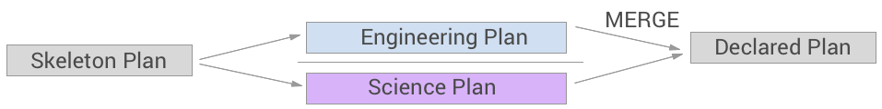

1. Similar to the previous scenario but involving multiple science and engineering teams working on plan fragments. This approach does not lead to many conflicts, since individual teams tweak their own activities only. Activity planner then merges all plan fragments into a single valid plan, while ensuring plan level constraints are met.

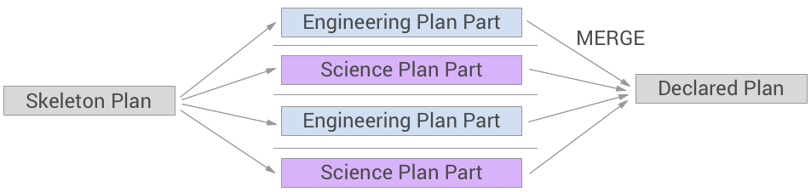

1. A pseudo real-time collaborative editing is adopted by some missions where multiple roles can work on the plan at the same time. A plan is initiated from a template where a generic set of activity instances are created beforehand. The edits authored by each operator is committed in real-time and merged. Conflicts can be handled with a mission dictated process. Permissions regulate what can be edited by which role to avoid unintended conflicts.

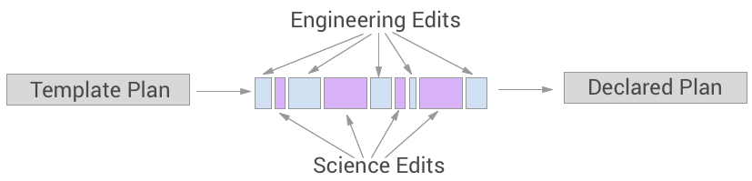

Note that many modern missions tend to adopt collaborative editing paradigms. The siloed planning between science and engineering often leads to hard to resolve merge conflicts too late in the planning process. While certain parts of the plan will be owned by a single authority or a small team, the main benefit of collaborative editing is to communicate effects of certain edits to the larger team as immediately as possible.

However, a non-restricted collaborative planning can also be detrimental in mission operations where users may override each other’s edits intentionally or unintentionally. While it is key for all users to be able to view and access latest state of an activity plan, editing permissions are often is restricted with various paradigms. For instance, in Mars 2020 only few roles are given all edit permissions, while sub-system and instrument representatives are only allowed to edit their own activity parameters and constraints. Europa Clipper is planning to adopt a more restrictive approach where a ‘master’ plan can only be edited by approved users. Other users can duplicate the master plan, edit it freely in their sandbox. They can submit the edited plan to be merged with the ‘master’ plan. The permissioned master plan owner can accept or reject submitted edits after review. Conflicts during the merge can be handled with a mission specific manual process.

## Plan Progression and Approval

A plan goes through many stages during planning with improving maturity. Activity plan participants need to understand the current maturity state of the plan since there may be restrictions in what can be edited in a plan at various stages. Once a plan is reviewed and finalized by the planning team, the plan has to be submitted for approval.

The Mission Manager must approve the activity plan before the uplink process can move forward. A mission’s approval process may be formal or informal. At the informal end of the spectrum, the activity planner and the Mission Manager discuss the plan before the Mission Manager approves it. At the formal end of the spectrum, the Mission Manager chairs a review of the plan before approving it, and signs a form in the end. Regardless of the formality, the review process has the activity planner explaining the intent of the plan, its highlights, its benefits and drawbacks versus alternative plans, and the predicted impact on key spacecraft system resources.

## Roles Involved & Permissions

The owner of plan in most missions is the Activity Planner. However, other roles including Science Team Members, Instrument Scientists, Instrument Engineers, and Sub-system Engineers participate in planning either through communicating their needs to the Activity Planner, or by directly interacting with the planning tool.

Note that in older tools where roles and permissions could not be regulated dynamically depending on the staffing per plan, the access to the planning tool may be highly restricted, even to a single role. More contemporary planning tools allow collaborative editing of the plan, while reserving critical editing capabilities to the activity planner.

## Capabilities Needed in Activity Planning

* **CRUD operations for activity plans** – allow a user to create, read, edit, and delete activity plans.
  + Define plan boundary
  + Define global resource constraints
  + Define plan level scheduling constraints (scheduling logic)
* **CRUD operations for activity instances in a plan** – allow a user to create, read, edit, and delete activity instances.
  + Allow searching activity type dictionary to add an activity instance to a plan manually.
  + Allow automatic instantiation of activities based on constraints and decomposition.
  + Allow activity instance parameter editing in a plan.
  + Allow editing activity instance schedule manually (for missions that allows manual scheduling).
* **Support automated scheduling of activities** 
  + Allow using Advanced MPSA scheduling service to schedule activity instances based on constraints via backend services.
  + Allow using mission adaptation algorithms to schedule activity instances based on constraints via backend services.
* **Support constraint checking and plan advisor** – Given a schedule of activities, check activity level constraints to ensure all activities are scheduled and all requirements are met for the healthy execution of the activities.
* **Support plan simulation at activity level** 
  + Given a scheduled activity instance with all parameters, and INCON, calculate resource effects per activity.
  + Given a plan with scheduled activity instances, calculate aggregated resource effects over time.
* **Support collaboration regulated with permissions** –
  + Allow users to create / duplicate plans that they can edit freely.
  + Allow merging plans to incorporate edits of multiple users.
* **Support plan approval process** – Allow missions to define stages indicating maturity level of a plan (e.g. skeleton plan, declared plan, approved plan).
* **Support versioning, change log and undo during planning** – Support plan versioning at mission specified intervals via backend services.
* **Provide a plan API** – Allow external tools or backend services to query contents of the plan and modify the plan.

# Sequencing

A sequence is a series of commands to instruct a spacecraft. While an activity is a construct for humans to think about spacecraft behaviour, a sequence can be thought as instructions that communicate to the spacecraft details of how to perform the activity. In missions where activity planning is performed, a sequence can be thought as implementation of an activity instance in the plan. During sequencing, sequences that are not associated with an activity are commonly created. However, almost all activities in a plan map to a sequence. Commonly, the association between activities or activity instances are achieved through assigning sequence IDs to activities, and delivering sequences with those IDs. Sequence ID assignment can be automated in some missions.

Note that sequences are intermediary products still constructed by humans, so they are human readable. Actual products radiated to the spacecraft are compiled versions of these sequences. The details of this process are discussed in Section 6.6.

## Sequence Generation

In its simplest form, sequences are authored by instrument and sub-system engineers manually for a given planning period to achieve desired science and engineering goals respectively. In missions where activity planning is performed and activity types are complete for commanding, meaning that, an activity instance contains all necessary information to create a sequence for the activity, the sequence generation can be automated by means of various constructs described below. This process is often referred to as *sequence expansion.* Different approaches to sequence generation that we encountered are as follows:

**Manual:** A sequence engineer types a set of commands that faithfully implements the activity declared in the plan. There is no automated validation performed to ensure that sequence provided actually implements the activity in the way it is intended. Hence, in theory the same activity can be mapped to completely different sequences. Sequences delivered in this fashion can be reviewed line by line during planning meetings. Sequence engineers perform this task using specialized command editors with real time syntax verification against command dictionary support. These editors validate command stems, parameter units and ranges. MPS Editor, MSlice for MSL, Sequencer for Mars 2020 are equipped with these capabilities.

**Reusable:** These sequences are created once and reused as is, without any edits during the planning and sequencing period. No activity instance parameter is utilized in these sequences.

**Template:** Some activities map to sequences where only few command parameters differ based on activity instance parameters specified in the plan. Such activities can utilize a template expansion, where the sequence engineer authors a template file dictating which command parameters have to be replaced with which activity instance parameters. The replacement takes place when the expansion is triggered, and a sequence file is then generated.

**Ground Expanded Block:** A sequence can be automatically generated for an activity using macros, which take activity instance parameters as input and return a set of commands.

**Script Team Tools:** Similar to ground blocks, scripts can be used to automatically generate sequences for a given activity instance. Most common scripts concatenate commands based on activity instance parameters. Scripts allow for more complicated logic to be utilized in command generation compared to blocks.

**On-Board Block:** These are function-like constructs or macros that are part of the Flight Software. A sequence that is executing on board can invoke an on-board block with parameters specified in the sequence, which returns a set of commands.

**Flight Software Behavior**: Behavior is a similar construct to on-board blocks. A single call to the Flight Software expands into a set of commands which can vary by input parameters.

## Sequence Delivery and Collaboration

Sequence delivery workflows vary significantly across missions. However, in general an association between activities in the plan and the sequences that implement those activities are achieved through sequence ID assignment to activity instances in the plan. Hence, it is possible to infer from a plan which sequences would be included in uplink products to a large extent.

Earlier missions utilized a shared project space to store of plan versions and sequences declared in the activity plan. Sequences generated by various team members would be collected by means of copying and pasting into a directory in a machine accessible over network, or by uploading to a database indicating the planning period. Sequences could be drafted before delivery, which indicates that sequence is not yet validated. Sequences are delivered after standalone validation, and approved after integrated validation. Only approved sequences can be included in an uplink product.

## Backbone or Background Sequence Generation & Sequence Integration

Sequence integration means having all sequences that are declared in the plan. It is a necessary step before validating all sequences at once to account for interactions among sequences, and to check flight rules that involve multiple sub-systems or instruments. The plan can be a complex data structure or a simple spreadsheet. Collecting sequences in a storage area can be done manually or missions can adopt automated delivery procedures through APIs. Missions often utilize a script to determine whether all sequences declared in the plan or a spreadsheet are delivered prior to sequence integration.

In certain missions, especially in Mars surface missions, sequence integration requires generation of a backbone sequence which will kick off each individual activity sequence at the execution times specified in the plan. These backbone sequences are often referred to as master and sub-master sequences, where sub-masters chain a series of sequences that are supposed to run one after the other, and masters kick off sub-masters at specified execution times. This leads to a relative timing within sub-masters, while master sequence ensures execution of these blocks in absolute time points.

Certain orbiter missions work with mini sequences which contain all activity sequences of an instrument or a spacecraft. These could be considered a counterpart to a sub-master, however, these are not kicked off by a master. Mini sequences are uplinked to specific sequence engines to be kicked off at the time specified within the mini sequence itself. In this paradigm, missions do not generate a master or a backbone sequence, but rather create a background sequence which contains all mandatory engineering activities such as communication activities and maneuvers. These activities in the backbone sequence imply exclusion zones for science activities which are considered during planning. However, there is no interaction between the background sequence and mini sequences on the spacecraft.

Note that missions adopting automated on-board scheduling might not need to generate such backbone sequences. Hence it is important for planning tools to interface with different scheduling services.

## Sequence Validation And Flight Rules

Sequence validation generally consists of two distinct steps. The first step is the standalone validation where sub-system engineers and instrument engineers validate their sequences per activity type in the plan in isolation before delivery. The second step is the integrated validation where all sequences are simulated and validated together in the order they are invoked by the backbone sequence. While standalone validation does not deal with an initial conditions (incon) state, one of the inputs to the integrated validation is the incon file which describes the state of the spacecraft to be assumed at the beginning of a simulation.

Most missions use a SEQGEN adaptation to validate their sequences. SEQGEN generates a sequence command walkthrough, modeling each command at the time and order that the sequences dictate. During this command walkthrough, Flight Rules that are hard coded in the SEQGEN model are checked. The modeling and Flight Rule checks in SEQGEN are adaptations implemented by missions.

Early SEQGEN adaptations suffered from Flight Rules being embedded and repeated in command models. This led to many challenges with regard to updating and editing Flight Rules. Many Flight Rule warnings are accepted as known idiosyncrasies, instead of eliminating them from the SEQGEN adaptation.

More recent SEQGEN adaptations address this limitation to a great extent by isolating modeling and flight rule checks. Nevertheless, a more formal approach to defining and a more automated approach to updating flight rule checks based on formal definitions would be highly desired by the vast majority of missions.

Note that many missions use custom tools to perform validation and Flight Rule checks. They still use SEQGEN to produce a PEF (Predicted Events File), which is a command walk through of all sequences in the plan. The PEF is then post processed by mission specific tools for validation.

A new trend in sequence simulation and validation is to use stubbed Flight Software code instead of an adaptation, which is less abstracted from the actual execution. To achieve this, Flight Software is modified to skip or emulate certain hardware behavior. The log files generated by the flight software simulation tool is post processed to validate Flight Rules. This approach also allows an ideal separation of simulation code from Flight Rule definitions. Aerie is going to adopt a similar approach to ensure separation of concerns.

## Review Sequence Simulation Results

During uplink operations sequence walkthrough is a common step where violated flight rules are discussed. The violations have to be either eliminated or dispositioned. Critical flight rule violations will require an official waiver from the mission manager. For integrated sequences, the sequence call tree is also reviewed to validate sequence execution meets intent.

## Generation of Uplink Products and Reports

Uplink product generation refers to the translation of integrated sequence files into compiled binary products that can be radiated to the spacecraft. Generation of uplink products starts after integrated sequences are formally approved by the Sequence Integration Engineer (SIE). Any flight rule violations that are waived for the planning period generally require formal approval of the mission manager, and must be stated in automatically generated reports. These reports generally include science and engineering objectives, expected outcomes, limitations, and violations that are being waived. While certain parts of report generation is automated, science and engineering goals are reported as attached user inputs.

During this process, SIE, also adds any files that need to be loaded onto the flight system, along with the commands to store them in the appropriate location. The generation of ready to be radiated binary products and reports is highly complicated, and almost entirely command line driven. A few missions require confirming the translation by reverse translating the binary file and comparing the source and reverse translated files. This comparison is automated and results reviewed through automatically generated reports.

The Mission Manager must approve the command package before it can be uplinked. This approval process is usually more formal compared to activity planning approval. SIE explains the intent of the sequences in the package, its highlights, and any constraints or flight rule violations that remain. The Mission Manager would need to issue a waiver for any such problems. After then, The Mission Manager approves the command package.

## Capabilities Needed in Sequence Generation and Validation

* **Support environment setup** – Allow user to set command dictionary version to use and switch between multiple command dictionaries.
* **Support manual sequence authoring** – allow a load, browse, and select commands from a command dictionary.Allow user to add / edit / remove commands to a sequence file. Assist users during sequence editing with real time syntax verification against a command dictionary**.**
* **Support associating sequences to activity instances in a plan** – Allow user to select an activity instance in the plan to associate with the sequence.
* **Support a sequence delivery according to processes defined by the mission** –Allow user to deliver sequences to a specific plan period either through Aerie platform UI, or directly to the mission data stores through a backend service or API.
* **Support library sequences** – Allow user to store sequences that are repeated without any edits throughout the mission.
* **Support template expansion authoring** – Allow user to select an Activity Type from the Activity Dictionary that the expansion will be associated with such that when the user triggers ‘expand’ for that activity, the template will generate the sequences using the parameters from the activity instance.
* **Support scripted expansion or ground blocks authoring** – Allow user to select an Activity Type from the Activity Dictionary that the expansion will be associated with (e.g. when the user triggers ‘expand’ for that activity, the script or block file will generate the sequences using the parameters from the Activity Instance)
* **Support on-board blocks viewing** – Allow operators to view expanded on board blocks.
* **Support versioning of dictionary sequences and expansions** – Allow missions to maintain a validated version dictionary sequences and expansions to be used in operations.
* **Support a backbone sequence generation** – Support automated generation of backbone sequences, like master / sub-master sequences based on activity instance schedules, and associated sequences in the plan via backend services. Allow missions to plug in their backbone sequence generation tools by querying the plan API and delivering the backbone sequences to uplink data stores.
* **Support command level simulation as a backend service** – Allow missions to create command level models in SEQGEN calculating effects based on command parameters and spacecraft state.
* **Support Flight Rule definition and editing** – Allow mission operators to define and edit Flight Rules that will be imposed on sequences on the ground.
* **Support standalone sequence validation and Flight Rule checks** – Allow sequence authors to perform standalone validations including syntax verification and applicable Flight Rule checks that do not require knowledge of spacecraft state or do not depend on other sequences.
* **Support sequence integration** – Provide the ability to check for completeness on all sequences that need to be delivered.
* **Support integrated sequence validation and Flight Rule checks** – Allow users to simulate integrated sequences and perform complete flight rule checks.

## Capabilities Needed in Uplink Product Generation

* **Allow Flight Rule violation dispositioning and waivers** – allow users to waive flight rules, provide rationale, and share with other users for review.
* **Support uplink product generation** –Translate the integrated sequences into compiled binary products to be radiated.

# Spacecraft Analysis

Spacecraft health and safety, along with success of plan execution has to be monitored during mission operations. Since this assessment involves analysis of data downlinked from the spacecraft, it is often referred to as downlink operations.

## Downlink Data Types

There are several types of data that are downlinked from a spacecraft. Telemetry is a generalized term for all data downlinked from a spacecraft. Most telemetry is channelized, meaning recording of a single state over time, such as data recorded by a sensor. Telemetry channels may be sampling status over a specified frequency, or updating value only when a change is detected. Data file / product type of telemetry is also common. On board memory status dumps are a good example of this type of telemetry. Telemetry products that indicate health and safety of a spacecraft are often classified as EHA (Engineering Health and Accountability) data. EHA can include channelized telemetry or data products.

| EVR Category | Description |
| --- | --- |
| FATAL | Used to capture the detection of an extreme failure in flight software logic. For this category only, the flight software will generate a response after generating the activity report |
| WARNING_HIGH | Used to capture the detection of System fault conditions and capture fault response events of interest. |
| WARNING_LOW | Used to capture the detection of local fault conditions and capture fault response events of interest. |
| COMMAND | Every executed flight software command will automatically have two associated Command activity reports – a Dispatch activity report and a Completion activity report. |
| ACTIVITY_HIGH | Used to capture the detection of high-level, nominal events of interest. Examples include Launch Vehicle Separation and Spacecraft Mode transitions. |
| ACTIVITY_LOW | Used to capture the detection of low-level, nominal events of interest. Examples include low-level memory check complete. Because of their low priority, ACTIVITY_LOW activity reports may not be downlinked on a regular basis during mission operations (although they will be regularly downlinked during the TEST spacecraft mode). |
| DIAGNOSTIC | Typically used to provide visibility into low-level code execution and to facilitate unit and integration test. |

Table 3 – Categories of EVRs (Event Records) produced by the Flight Software.

EVRs, Event Records, are another important data for downlink analysis. These are log entries produced by the Flight Software encoding command invocations, success or failure of command execution, alarms, warnings.

Other than these instrument engineering data products and instrument science data products are other categories of downlink data sets. Figure 10 illustrates that science and engineering data sets downlinked feed back into science and engineering planning for the next planning cycle.

Spacecraft subsystems and instruments must systematically monitor and interrogate the EHA and EVR data to ascertain the health of their subsystem or instrument. For each spacecraft, downlink bandwidth is a limited resource that must be shared between engineering and science data. Typically, a certain amount of bandwidth is reserved for engineering telemetry, and certain channels of telemetry are pre-configured to come down at each single downlink pass.

The data that comes down in a pass is processed by the mission’s ground data system and is turned into a number of engineering data products. After the data is processed, sub-system and instrument engineers analyse the data using a variety of tools, many of which are home grown, such as Matlab or python scripts. Typically, the workstation of downlink operator will have several dashboards and screens configured to show data in a format that is most useful to them. MSL downlink teams created a rich suite of dashboards as shown in Figure 12. Downlink operators are also responsible for identifying anomalies and leading investigations to understand, advise and mitigate spacecraft health issues. In the event of an anomaly, science data is put on hold and all engineering data and logs are downlinked.

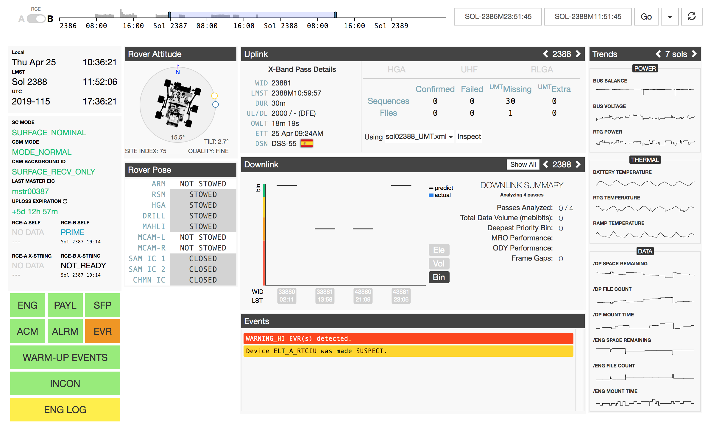 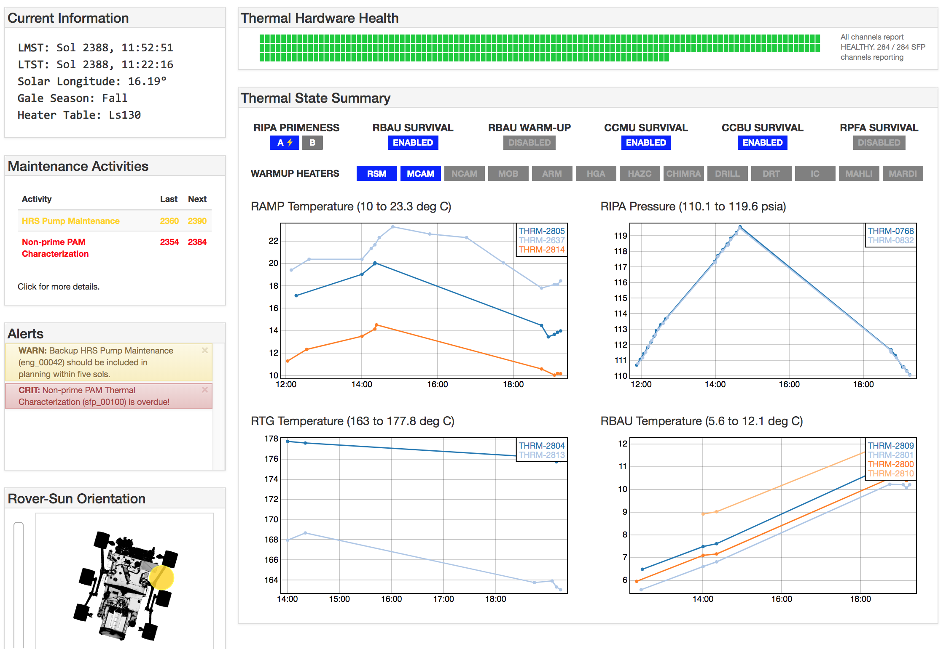

Figure 12 (right) MSL System dashboard summarizing overall spacecraft health and safety. (left) Main thermal sub-system dashboard.

## Goals of Spacecraft Analysis

The primary goal of downlink analysis is to ensure spacecraft health and safety. If any anomalies are detected, the reasons behind has to be investigated. The assessment part of the problem can be automated to a great extent by evaluating pre-defined rules. We plan to extend Rule Based Operations, as pioneered on Mars 2020, to a multi-mission scale with a richer set of rule types.

On the other hand, the diagnostics part of the problem requires open ended investigation, hence flexible data analysis and visualization tools. Mars 2020 is adopting Jupyter notebooks to address this need. Having a deep know how on telemetry data visualization, Aerie team is committed to providing flexible data visualization tools for downlink analysis. We plan to couple visualization tools with interactive filtering and simple statistical operations to allow engineers perform simple investigations.

Most downlink operations focus on anomaly detection and diagnostic capabilities. However, there are many areas downlink analysis tools can be improved. We discuss these under Section 7.4.

## Variations in downlink operations

The loop of analysis varies with the mission activity planning cycle. As such, the loop is tighter on rovers than on orbiters. For example, a Mars surface mission might have a daily process, while an orbiter might have weeks long operations process. This can be a source of pain for missions with shorter planning cycles, translating data into meaningful information for assessments and uplink planning requires mental effort and labour.



Figure 13 – A spectrum of mission variability in downlink operations.

Generally, the loop of analysis is also is also influenced by risk posture and complexity. For more complex missions, the downlink health and safety assessment is a necessary input to planning, whereas simpler missions typically focus less on analysis and more on modelling. The latter tends to be more automated than the former. There are generally three levels of automation:

**Fully Manual:** An operator is on console to monitor each pass.

**Hybrid:** An operator is on console at specified times and has automated alarms.

**Fully Automated:** Automated monitoring; operators on console only in response to alarms.

When day-to-day downlink operations is more automated, the operators can focus their efforts to tackle specific research questions. For example, one investigation could look at power levels trending over time and in different environments to understand the efficiency of current battery usage. Such questions can take months of data analysing to answer and develop a proposal for changing a model, flight rule, or process. These downlink operations are highly de-coupled from uplink operations.

## Desired Capabilities for Downlink Operations

### Trending Data Analysis

Probably the secondary goal of downlink analysis to characterize spacecraft behaviour more accurately by performing trending data analysis. Such trending analysis can help predict when certain critical states might be reached, help detect behaviour patterns that take place over long cycles, and improve our modeling and operations in general. For instance, trending data analysis performed by the MSL telecommunications team significantly improved the downlink return volume prediction of the mission. Hence, downlink data analysis and visualization tools should provide access to aggregate data.

### Correlate Simulation Data and Telemetry: Closing the U

Improving models and diagnostic investigations often require comparing telemetry from spacecraft to various simulation data. For instance, performance of resource models can be evaluated when compared to actual resource consumption on board. Similarly, many diagnostic inquiries may require looking for similar anomaly in testbed data. Even if both data stores would be accessible from the same data analysis tool, data correlation is still a challenge due to mismatch in what is modelled in an adaptation versus what FSW outputs. Adaptations should be created with Downlink analysis tools should allow analysts to define mappings between these data sets in order to render this correlation possible.

### Correlate Data Products to Activity Plans

A challenging task for downlink analysis is to determine whether the plan executed as intended. For engineering, this can be done by reconstructing sequence execution timeline from EVRs, and comparing that to the planned activity schedule. For science, it’s more complicated, and generally involves mapping science data products to activities in a plan manually, so that conditions that led to the observation can be understood by the science team. For instance, for a given image, how instrument was pointed when the image was taken, what was the exact target, what time the image was taken are all useful contextual information. Some of this information can be gathered from sequences that produced the data products, however activities mapped to data products can simplify the workflow especially for science team.

## Summary of Needed Capabilities

* Visualize telemetry
* Define, evaluate and display rules for automated assessment of spacecraft health and safety
* Allow operators to juxtapose data sources on demand to support open ended investigations
* Allow correlating simulation data and telemetry
* Allow trending data analysis by providing aggregate data and applying statistical operations
* Allow correlating activity plans to data products

# General Design Principles for Aerie

## Background, Objectives, and Scope

In this section we will describe the capabilities for the generic UI components of the Aerie platform. When utilized in applications tailored for mission processes, mission operators will interact with these UI components to achieve the mission operation concepts and capabilities in the previous sections.

## Operational Policies and Constraints

In order to proceed with a modular architecture, we must identify reusable generic components that can be utilized at multiple stages of mission operations, for different purposes, and more importantly, across missions. We expect certain missions to have custom needs for some of these components. In those scenarios, mission adaptations should be able to extend existing UI components to satisfy such custom needs.

## Desired Characteristics of the Aerie Platform

Besides the capabilities identified to support the planning and sequencing operations, the Aerie platform should offer a set of overarching capabilities to simplify user workflows, guide processes and ensure security. These characteristics are

### Supports Collaborative Editing

Adaptation built with the Aerie adaptation framework should support collaborative editing, where multiple users can access / edit a plan or a sequence file and other users can view these updates almost immediately. Such applications should support carefully designed undo features to manage conflicts.

### Supports User Permissions

Adaptations built with Aerie framework should support different permission levels for different users. The permissions can be defined at different granularities. While some users will have only read only access and others can have all editing privileges. Intermediary permission levels where users can edit only certain attributes shall also be supported.

### Supports Versioning of Underlying Data Structures

Aerie platform applications should support users to store tagged versions of underlying data structures on demand. The applications should allow users to view different versions, to revert to an older version on demand.

### Supports Deep Linking

Web applications built with the Aerie platform components should support *deep linking*, allowing users to share, or other applications to link to a specific content within the web application. The same mechanism can be used to support interaction between components within an application.

### Easy to Interface with External Tools

Aerie tools shall provide APIs to allow external tools to create and edit activity and sequence plan records.

### Performance Characteristics

The UI components should allow for flexible web applications, where any number of these components can be composed together for a mission operations task. The resulting web application should be dynamic and responsive to updates pushed by backend services. The data products or results generated by backend services should be displayed accurately. Displaying processed data should not introduce any significant delay. In other words, given the data is available, the display components should support real time interaction.

### Safety, Security, and Emergency Operations

This document captures the operations concept for the display components. The security requirements on this are contained in the relevant software requirements documents. Safety and emergency operations requirements are not relevant.

## Reusable UI Features

### Search Feature

Search component will be frequently used with other components. The component should support:

* Auto-filter
* Auto-complete

### Form Viewer / Editor

The form component can be used to create/edit activity types for a given schema, activity instances in a plan, or a command within a sequence. In all of these scenarios, the inputs must be validated against acceptable values defined in a configuration file or a schema. The form editor should support the following features. For command editing, we need the base features of:

* Allow user to update parameters
* Display parameter range and unit
* Display validation errors (based on validation against a source dictionary or schema)

For activity instance editing we need the additional features of:

* Allow user to add / edit constraints
* Allow user to manually input or override resource effects
* Allow user to compare activity instances.

For activity type editing we need the additional features of:

* Allow user to specify the instrument or sub-system that owns the activity type.
* Support users to follow naming conventions adopted by the mission.
* Allow user to edit / remove parameters.
* Allow user to define a new parameter with range and unit.
* Allow user to add / edit / remove constraints in the form of ENUMs or numeric values defined globally
* Allow user to describe resource effects in terms of expressions and formulas.
* Allow user to point resource effect calculations to external tools or scripts.
* Allow user to differentiate between parameters and constraints that can be and cannot be edited at instance level.

### Group Viewer / editor

The group editing component can be used to create activity types that consist of multiple other activities, or activity groups within a plan. The component should support the following:

* Allow user to group activities in a sequential order
* Allow user to group activities on a relative timeline to enable parallelism
* Allow user to define parameters at the group level
* Allow user to define resource effects at the group level
* Allow user to map group level parameters to individual activity parameters
* Allow user to review group level resource effects

### Constraint Viewer / Editor

Any activity type, activity instance can be constrained against a resource, a geometric event, or another activity or sequence.

* Allow missions to define supported constraint types for activity types
* Allow missions to define supported constraint types for activity instances
* Allow user to add/edit/remove constraint types
* Visually indicate constraints defined for activity instances
* Visually indicate any constraint violations and display diagnostics on demand
* Guide users to eliminate constraint violations
* Given a set of constraints, allow users to identify potential windows of execution for an activity instance

### List Viewer / Editor

Many missions handle planning by maintaining a time ordered list of activities. Especially for missions where planning cycles are long, these lists also serve as a succinct summary view. List views can also be utilized to display logs and violations. The list view should support the following:

* Allow user to add / remove elements from the list
* Allow user to update contents
* Allow user to filter and sort lists based on user specified criteria

### Table Viewer / Editor

Multi-faceted data structures that are used during planning and sequence validation can also be viewed in tables. Different from lists, table viewers align the same property or dimension of data across data points.

* Allow user to add / remove elements to the table.
* Allow user to update cell contents of a table.
* Support displaying graphical content in table cells.
* Allow user to sort by column.
* Allow user to add / remove columns to support high dimensional data representation for different use cases.
* Allow user to filter data points (rows) based on specific criteria.
* Allow user to colorize data points (rows) based on specific criteria.

### Timeline Viewer / Editor

Many missions perform planning by adjusting activity instances on a Gantt chart or similar timeline viewers. Gantt charts display one item in a row with labels listed on the left-hand side. More compact timelines can display multiple items in a row with labels. Timeline viewers can be static visualizations or interactive depending on how scheduling is performed.

* Allow user to add through text input.
* Allow user to drag and drop elements.
* Allow user to remove elements.
* Support expanding hierarchies on timeline (e.g. activity groups).
* Allow user to move elements on the timeline.
* Allow user to zoom in and out.
* Allow user to scroll timelines that exceed view.
* Display multiple time scales on an axis.
* Support automatic navigation animation to the activity that is specified by the user.
* Support smooth animations during navigation.
* Allow user to sort and filter elements (e.g. display only certain activity types).

### Smart Text Viewer / Editor

Smart text editors allow users to type freely while assisting them with auto-complete features and real-time syntax validations against a specified dictionary or library. Smart text editors more commonly used for sequencing, however, activity instances can theoretically be edited the same way.

* Allow user to select source library or dictionary for validation
* Support auto-complete while typing both for stems and parameters
* Auto-complete parameters with default values if defined, otherwise with parameter names
* Display units, ranges and default values for parameters on demand
* Allow user to suppress auto-complete
* Validate command stems, parameter types and ranges
* Highlight validation errors
* Display detailed validation warning or errors on demand
* Allow missions or users to specify a colour schema mapping to various attribute types in the dictionary
* Couple with a form editor to enhance editing of highly dimensional attributes (e.g. a command with 50 parameters)

### Expansion Viewer/Editor

Expansions are templates, functions or scripts that expand into sequences for a given activity instance and it’s parameters. Expansion viewer will require all the features described above for smart text editor.

* Allow user to specify an activity type that the expansion is being authored for.
* Allow user to view expansion and expansion output side by side (e.g. JSFiddle).
* Allow user to validate expansion and expansion output separately.
* Couple with a form editor to edit an activity instance for testing the expansion output.

### Diff Viewer

Mission operators often want to compare sequences or activity instances from different planning cycles or different historical versions of the same sequence or activity within the planning cycle.

* Allow user to specify data products to be diffed.
* Display data products to be compared side-by-side either in plain text or in a form view.
* Highlight differences line by line or item by item.

### Date Picker

Creating navigating plans typically involves specifying dates.

* Display dates in multiple mission specified time frames
* Allow user to select date in multiple time frames
* Support restricting time boundaries that a date can be selected within (e.g. select a date within the boundary of a plan)

### Map Viewer

Users often need to select targets for observation on a surface map. Additionally, a footprint of an activity instance for a given set of parameters is often reviewed on a surface map.

* Allow user to view a geographic surface map.
* Allow user to zoom in and out on the map.
* Allow user to scroll horizontally and vertically on a map.
* Allow user to select a point on the map to specify a target.
* Allow user to select a region on the map by brushing.
* Allow user to select a region on the map by drawing a polygon.
* Allow user to view calculated footprint geometry overlaid on the map.

### Target Management Component

Operators need to specify targets for observations. Targets can be in various coordinate frames. While target selection can be done on a map, a generic component should allow defining targets as text inputs in a specified coordinate frame without a map.

* Allow user to specify target in various coordinate frames (xy, xyz, lat-lon, az-el, etc).
* Couple with a map viewer component to instantiate targets based on selection on map.
* Allow user to update or delete targets.
* Allow user to assign names and IDs to targets.
* Allow user to tag targets with mission specified tags.
* Allow user to annotate targets with free form text.
* Allow user to annotate targets with image uploads.
* Allow user to search for targets based on name, ID, tags or other attributes.

### Timeseries Data Visualizer

Activity planning often occurs around fixed temporal events (e.g., DSN windows) or profiles (e.g., thermal profile). Users need to review these data sources on time axis to be able to plan other activities around them.

* Allow user to view instantaneous events on a timeline.
* Allow user to view line plots.
* Allow user to view non-overlapping temporal events on a single band.
* Allow user to zoom in and out.
* Allow user to read a higher precision value for a point on timeline on demand.
* Allow user to filter and highlight data points that are below or above a user defined value.

### Hierarchic Data Visualizer

Reviewing sequence hierarchies, where sequences are nested within other sequences, is a common need. Similarly, missions might allow deep nesting of activities within activity groups. Unlike generic hierarchical data, these data sets have temporal attributes.

* Support visualizing hierarchies as trees or dendrograms.
* Support visualizing hierarchies along with the associated temporal context.
* Support visualizing arbitrary depth hierarchies.
* Support collapsing and expanding children of a node on demand.

### Generic Visualization Container

Aside from the described visualizations above, missions might need very specific needs to visualize certain data products in specific ways. To support this, Aerie platform should support a general-purpose visualization library that can be contained in a component.

* The generic visualization component should interface with other components, enabling users to filter data points, modify visual mappings based on user interaction in other components.

### Electronic Signature Forms

As mentioned earlier, many validation steps will automatically generate reports in html or pdf formats.

* Support displaying html or pdf reports generated by other tools.
* Allow users to associate errors / warnings in reports to previously approved waivers.
* Allow users to annotate reports.
* Allow users to attach additional data to report such as image, pdf, ppt files, etc.
* Allow users to sign forms electronically.

## Summary of Impacts

In the short term, these display components allow users to access the capabilities of APGEN, view plans in a RAVEN-like display, without the latency of moving the data from one tool to the other. In the longer term, these display components allow customer missions to move from the current MPSA products to the new Aerie system without changing the interfaces their operators use.

## Operational Impacts

### Interface Changes

Aerie platform adopts web applications for all user facing tools to be used during mission planning and sequencing. Web applications offer significant benefits in terms of ensuring consistency of versions and experiences, ease of releasing updates, abstracting user interfaces from data processing backend. Most importantly web applications support deep linking, which allows users and applications to share or link views with specific content being displayed. This allows us to build interfaces tailored for specific purposes and link to other interfaces on demand with specified context.

On the down side, web applications introduce limitations in terms of speed and access. To be able to use these tools operators need to be on a secure network. Offline mode use should be considered in applicable cases.

### Procedural Changes

MPSA does not develop or prescribe mission operations procedures. On the contrary, the tall temple for Aerie platform is to be able to support any mission operations. The capabilities developed for these components are based on a wide range of mission processes. While we envision that new missions can introduce not accounted changes to processes, we do not expect these changes to render Aerie platform architecture completely incompatible.

### Changes in Data Sources

Aerie platform consists of thin clients developed to tap into different types of data stores through an API Gateway. Hence the data stores that a mission selects should not be affected by changes in the Aerie platform.

# Conclusions

The mission operations concepts summarized in this document are derived from interviews conducted with several individuals who performed operations in a multitude of missions.

Our research included Mars Surface missions and deep space orbiter missions operated by JPL and Lockheed. We did not include any Earth science missions since they do not perform activity planning and sequencing, but rather perform real time commanding to operate their spacecraft.

Our investigation covered missions that are in operations including MER, MSL, JUNO, DAWN, and MRO. We also investigated modern operations concepts that are currently being developed for upcoming missions including Europa Clipper, Mars 2020 and Psyche. Our interviews with these missions revealed that they try to address bottlenecks in operations by adopting automation at various points in their process. However, these processes still largely based on legacy missions.

Aerie Operations Concept document focused on gathering a comprehensive set of capabilities needed to support a wide range of missions. We do not expect all identified capabilities to translate into requirements. However, this document can inform to define and prioritize requirements for the gradual delivery cycles of the Aerie platform. For actual requirements for the platform, refer to *Aerie Software Requirements Document*.